This document is prepared for Data Visualisation Assignment. Below is the list of contents involved in this assignment.

**Name**: Deepti Balasubramaniam

**Student ID**: D20123887

**Course ID**: TU059 Data Science (FT)

Table of Contents:

1. Dataset
   1. Description
   2. Cleaning
2. Intended Audience
3. Data Exploration
   1. Description on each data exploration in Dashboard
   2. Interactive Dashboard and its purpose
4. Key Insights
   1. Explanation on Insights
   2. Dashboard along with suggestions
5. Previous Iterations
   1. Screenshots of explorations and Insights with the previous iterations

1.Dataset:

Dataset is taken from Kaggle refer the below link.

Link: <https://www.kaggle.com/jessemostipak/hotel-booking-demand>

1.a) Description:

This dataset describes two hotel one is Resort Hotel and other is City hotel. Both shares the same structure with 31 variables. Both the dataset comprehend bookings due to arrive between the 1st of July of 2015 and 31st of August 2017, including the bookings that effectively arrived and bookings that were cancelled(*ScienceDirect Full Text PDF*, 2018).

The data set has many interesting variables apart from Cancellations and reservations like Region from where customers are booking, Arrival Month, Repeated Customers, Meal Preferences, Leadtime (Advance Bookings), Deposit Type, Customer Type, Segment(Online or Group bookings). With this dataset will be able to perform an exploratory analysis on what basis bookings and cancellations are made, which will help the Hotel Management to increase their revenue and will be able to make predictions on cancellations. (*Antonio et al. - 2019 - Hotel Booking Demand Datasets.Pdf*, n.d.)

1.b) Data Cleaning:

As like any dataset this dataset too needs cleaning before analyzing. With the help of Python, have implemented few data cleaning methods

Followed below steps in python for cleaning the data.

* Save the hotel csv file using pd.csv as hotel.
* Hotel.isnull().sum() will give the total null values.
* Variables like country, agent and company have Null values.
* Check for percentage of Null values column wise using
  + print(round(100\*(hotel.isnull().sum()/len(hotel.index)),2))
  + Agent and company have more percentage of missing values therefore we can drop the column
* Removing the outliers from the data for more easy data exploration
* Save the cleaned csv file using hotel.to\_csv

(Refer the attached python code)

2.Intended Audience:

Hotel Revenue managers of City and Resort from hospitality department have huge revenue loss caused due to high cancellations on bookings, therefore they need a help of a Visual designer to give them some insights regarding the bookings and cancellations, which will help them to increase their revenue. They wanted the comparisons between the hotels based on the facilities, this would also help them to make necessary precautions in housekeeping, food and other available facilities on the hotel.

This Data Visualisation is intended for **Hotel Revenue Management** team. The data has been taken from Hotel’s Property Management system (PMS) and confidential information about the customers has been removed for privacy policies.

Myself, a visual designer will be looking for below data to give a proper solution to Hotel Revenue Managers.

* Historical Data-Collected from hotel’s Property Management System
* Performance Data
* Forecasting with the data
* Insights from the data provided and collected.

3.Data Exploration:

Data Exploration will start with analysis on data extracted from hotel’s Property Management System (PMS).

3.a) i. Region with Highest confirmed bookings

Knowing the customer type and their native will help the revenue managers to target the region for advertisements. Most visitors come from Portugal, followed by GBR and France.

3 a) ii. In which month most of the bookings are made.

It is always good to know in advance on which month the most bookings are made to make necessary arrangements.

August is the most demanding month for hotel bookings

3 a) iii. Which is most preferred room type?

Knowing the room type will make the house keeping work convenient

Room Type A is most preferred one

3a) iv. What is most Preferred meal.

Food wastage in one of the most common problem in hotels.At one time there is excess food and on other time there is shortage when special requests are made, therefore by knowing the most preferred meal type will help in saving time and money and would help in making the arrangements accordingly.

Bed and Breakfast is the most preferred meal by Special request guests.

3a) v. How many repeated customers are visiting the hotels?

Knowing the repeated customers will help the Hotel on areas of improvement and most liked facilities available.

Though the repeated customers are less in both the hotels, Resort hotel have more repeated customers compared to City hotel.

3a) vi. In Which year ADR was highest?

Average Daily Rate (ADR) is Sum of all lodgings transactions by the total number of staying nights. ADR helps in predicting which types of customers to attract, because at times hotel stay prices needs to be increased during the peak months to compensate the gain or loss. When ADR is more retired people will not be able to afford and at that time hotel team must target more towards high earning customers.

In 2017 ADR was highest for the hotels.

3 b) Overall Interactive Dashboard for Data Exploration:

**Please refer Tableau file or Tableau Public link for the interactions**

**[Click Here for Data Exploration Dashboard Tableau Public Link](https://public.tableau.com/profile/deepti4659" \l "!/vizhome/DVAssignmentV1_1-DeeptiD20123887/HotelBookingDataExploration)**

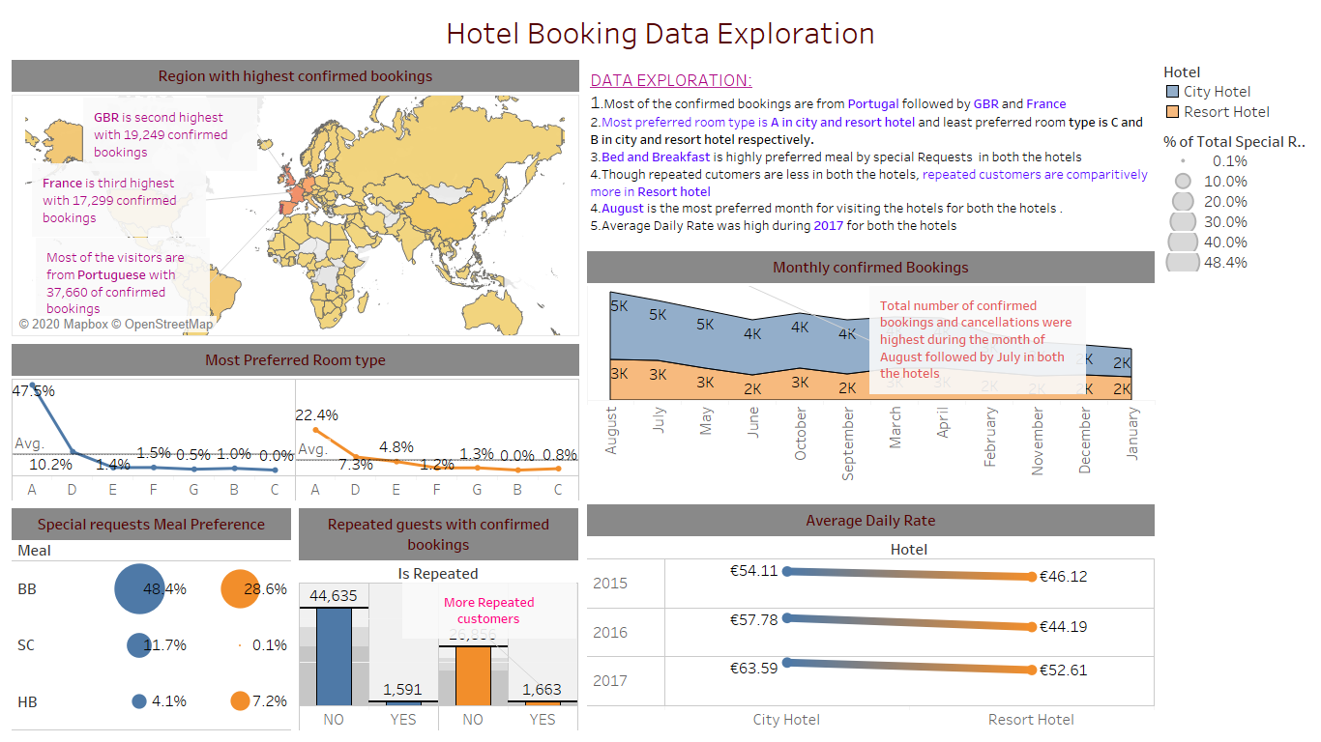

**4.**Key Insights

1.City Hotel has high cancellation Rate than the resort Hotel

2.Contract type customers have higher lead time (Advance Bookings) and have more cancellations

3.Cancellations are more for deposit type "No Deposit"

4.Most of the bookings are done through Online TA, Groups and Offline TA.

5.Customer from GBR and France prefer week stay in Resort Hotel

**Please refer attached tableau file or Public Link for Key Insights Dashboard**.

**[Click Here for Key Insights Dashboard public link](https://public.tableau.com/profile/deepti4659" \l "!/vizhome/DVAssignmentV1_1-DeeptiD20123887/BookingPredictions-INSIGHTS)**

4.b) Interactive Dashboard of Key Insights

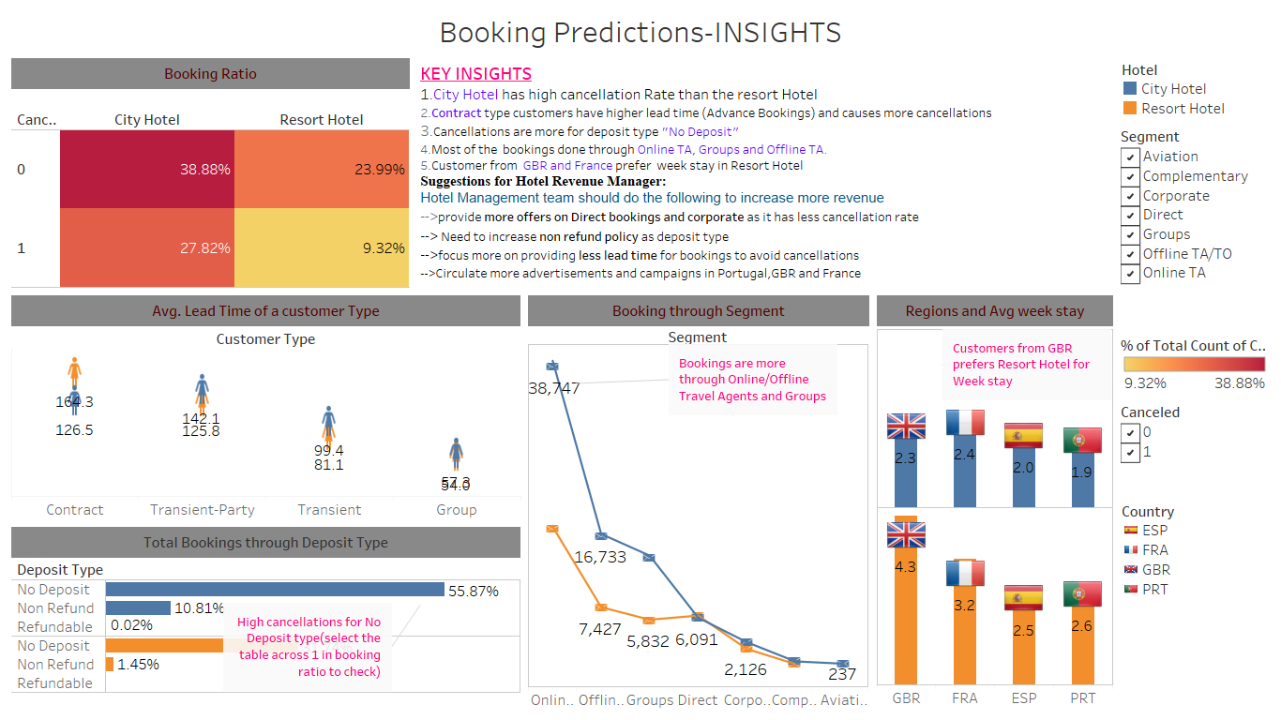

**Suggestions through Insights:**

Hotel Management team should do the following to increase the revenue

-->provide more offers on **Direct bookings and corporate** as it has less cancellation rate

--> Need to increase **non refund policy** as deposit type

-->focus more on providing **less lead time for bookings** to avoid cancellations

-->Circulate more advertisements and campaigns in **Portugal, GBR and France**

5.Previous Iterations.

Previous iterations contain the screenshots of different graphs taken during the exploration, Insights and also other charts which are not placed in the dashboard.

**Region with Highest Bookings:**

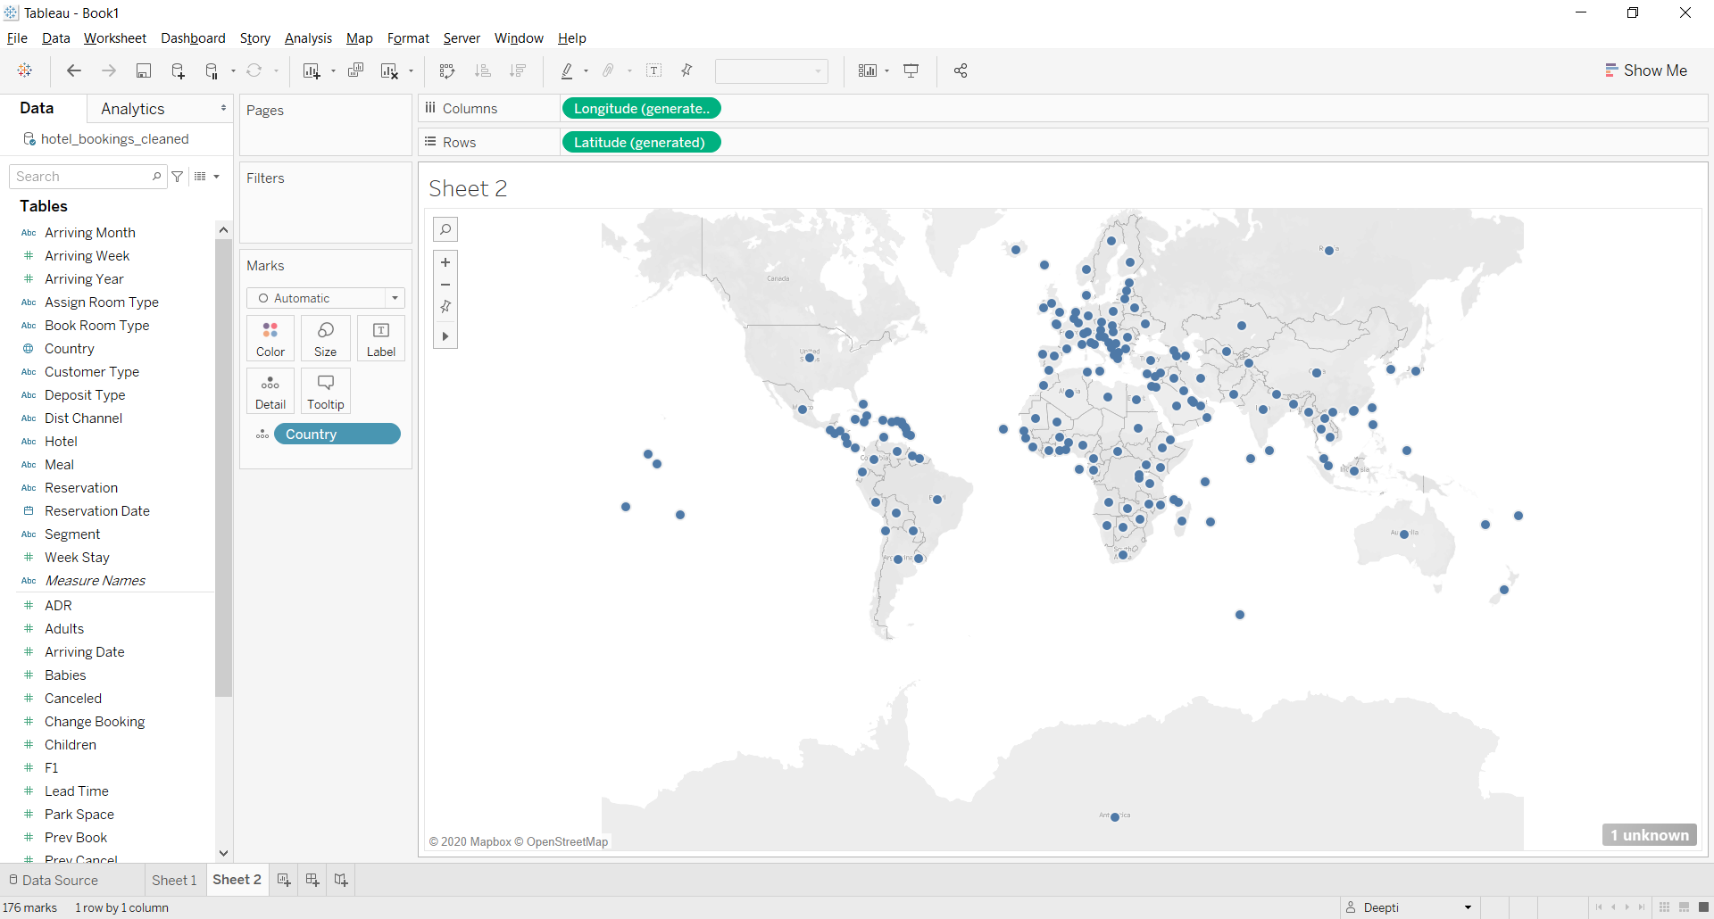 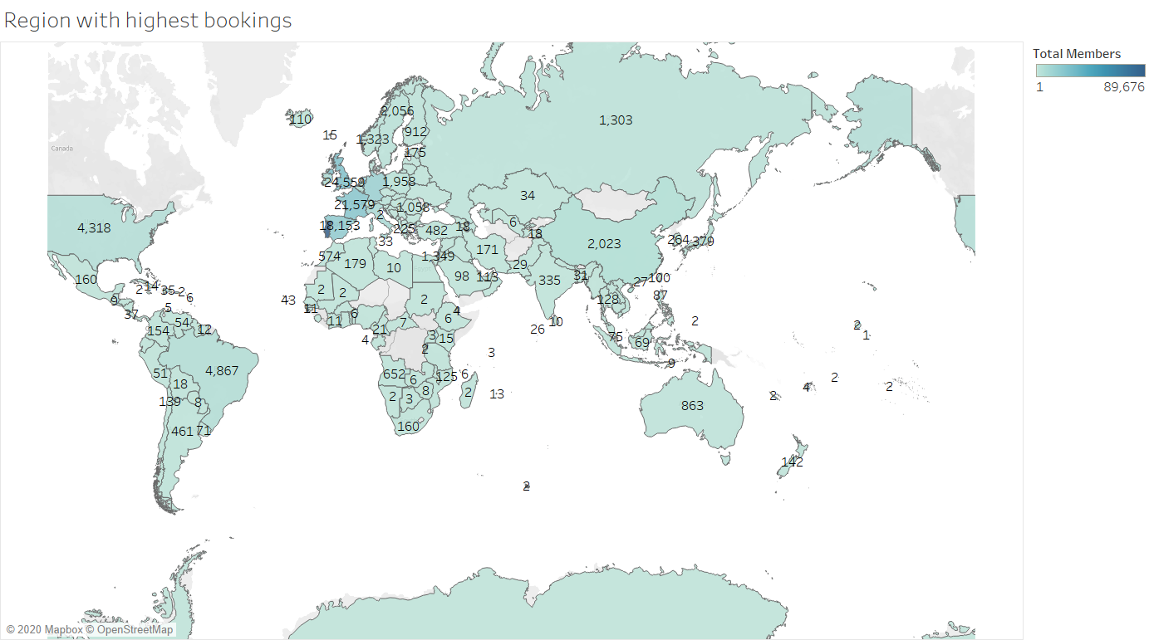

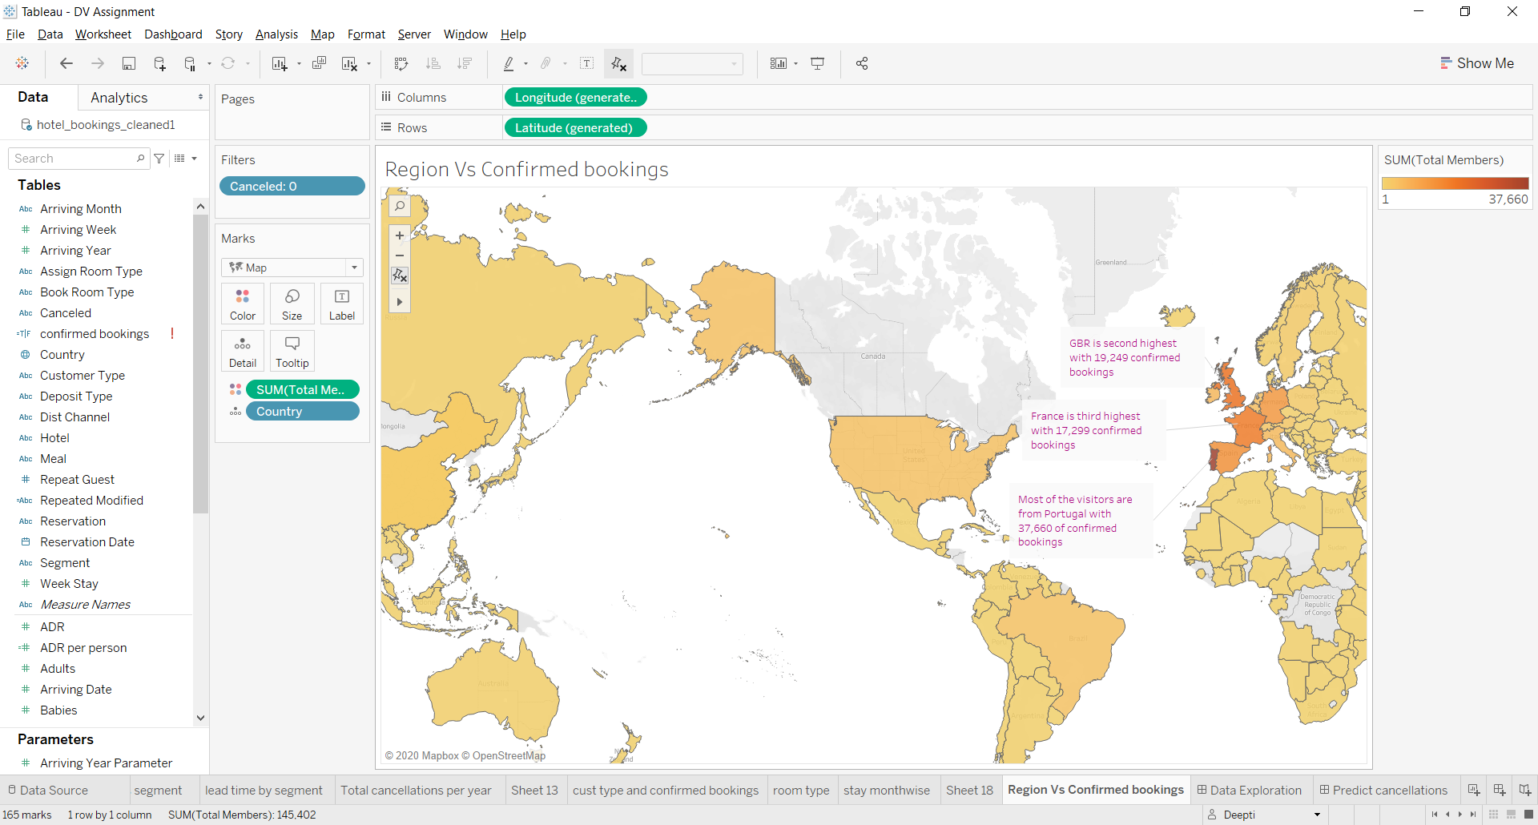

**Preferred Room Type:**

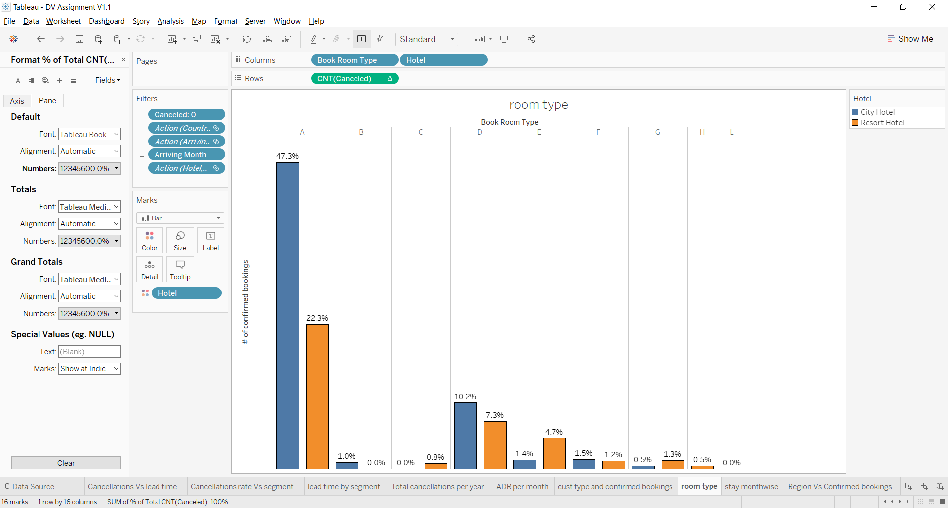 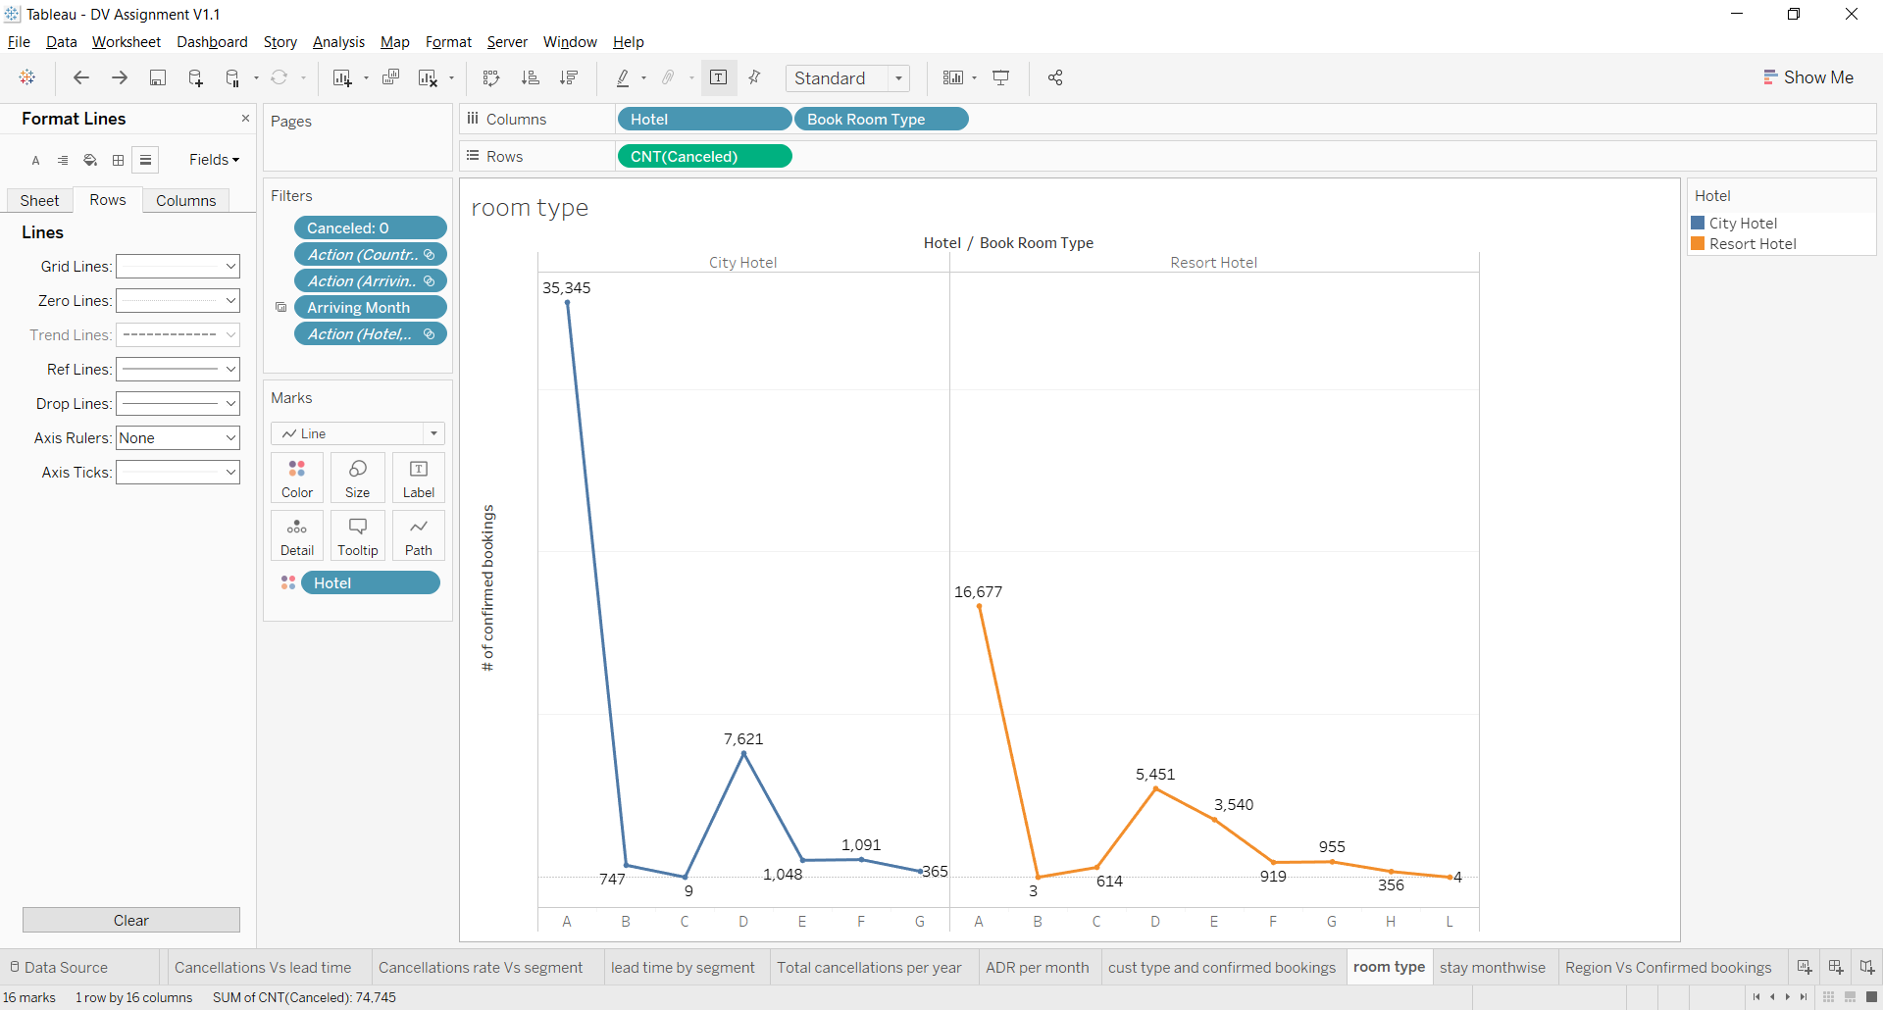

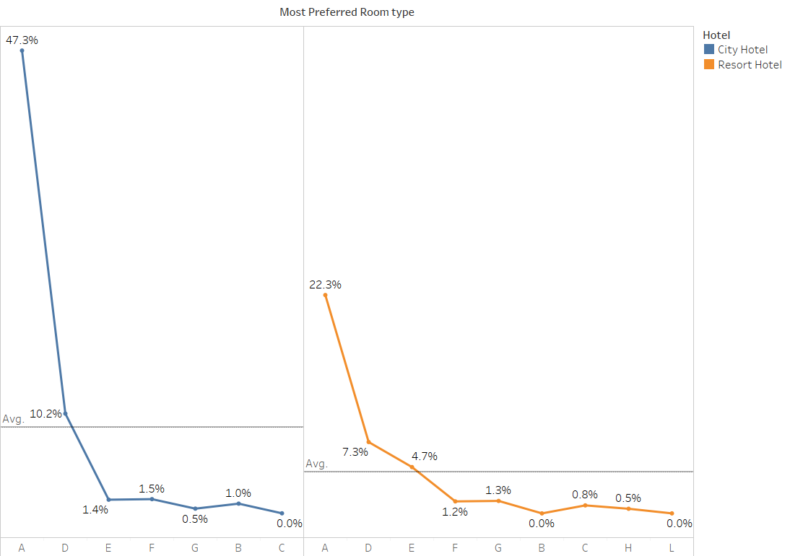

**Meal Preference of Special Requests:**

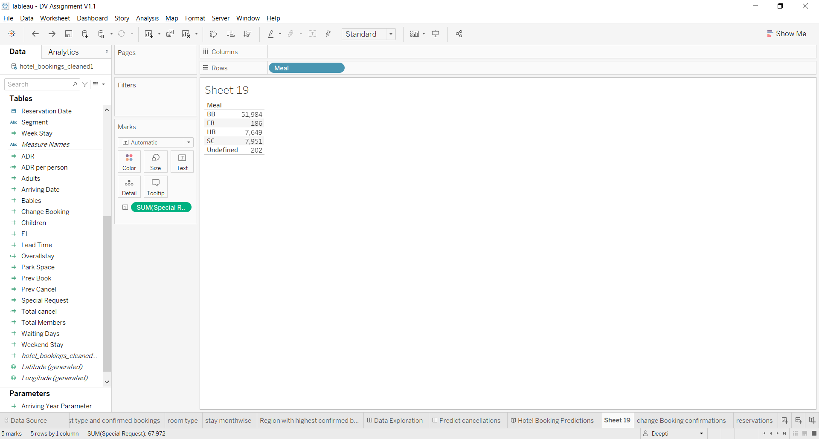 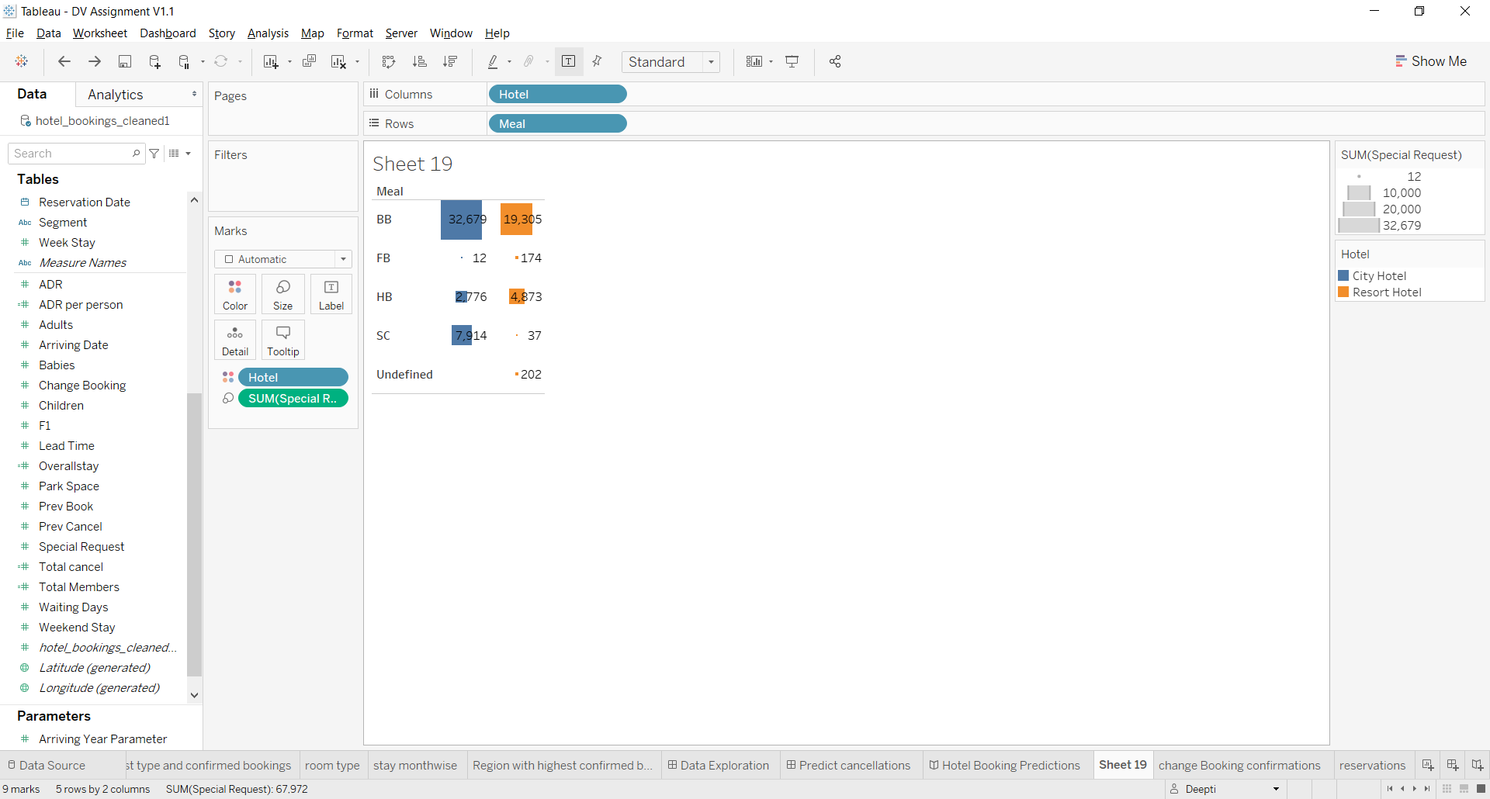

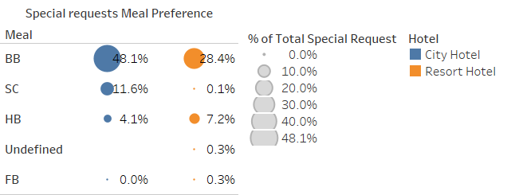

**Repeated Guest with Confirmed Bookings:**

Modify the Variable of Repeated customer as Yes or No in order to avoid confusion.

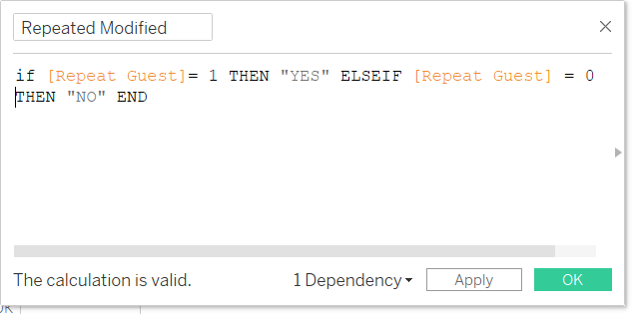 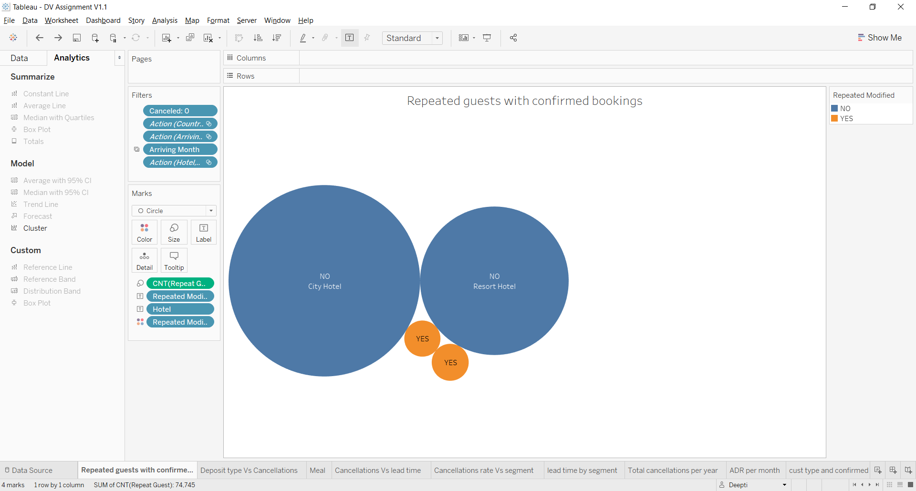

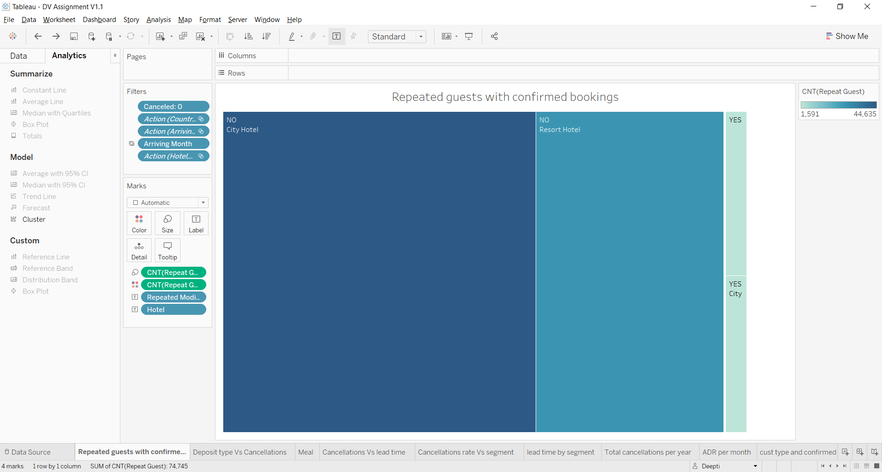 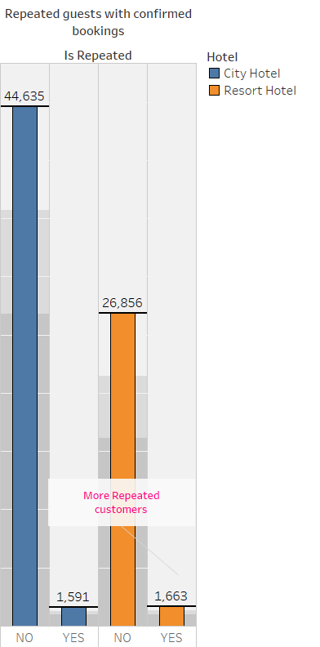

**Monthly confirmed bookings:**

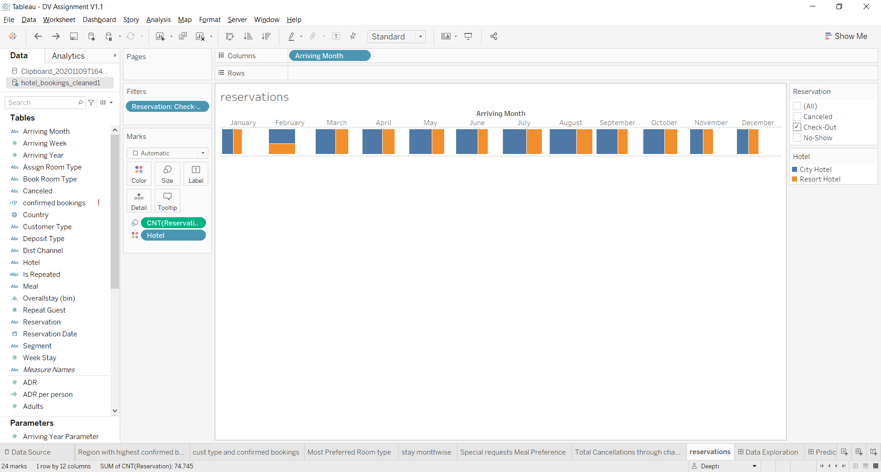 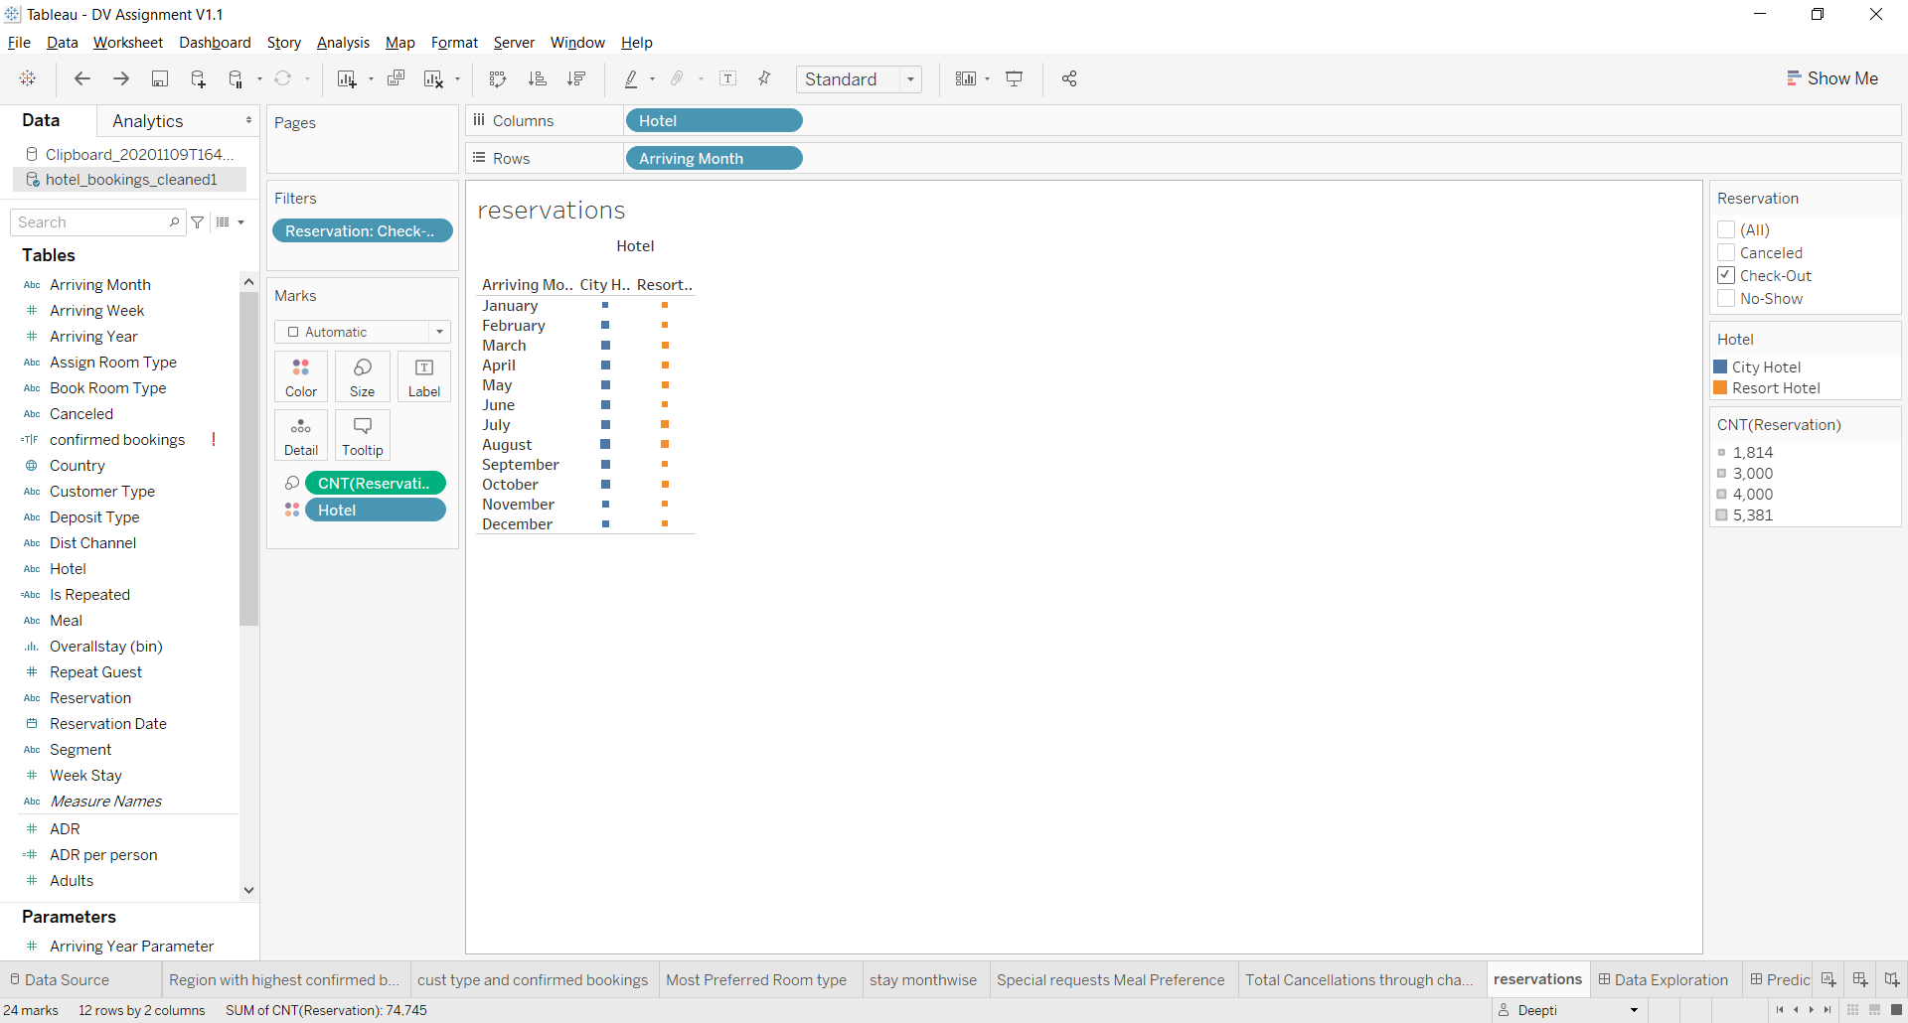

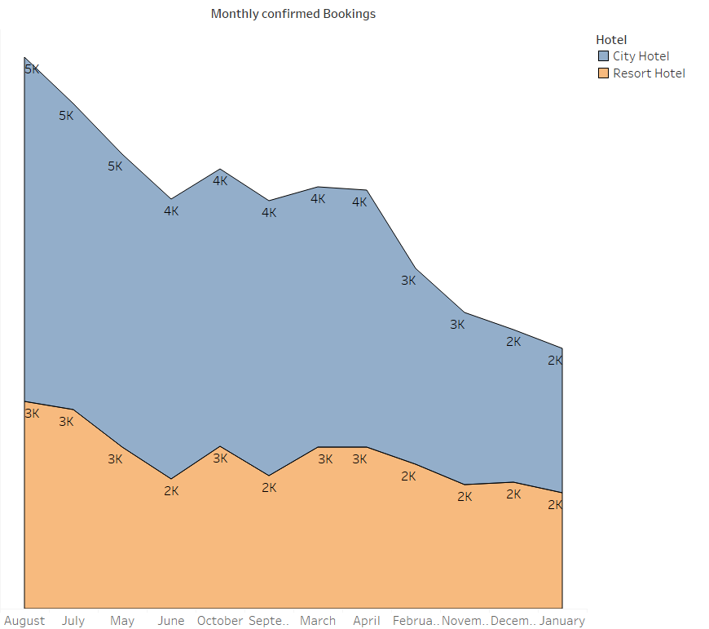

**Average Daily Rate per year**

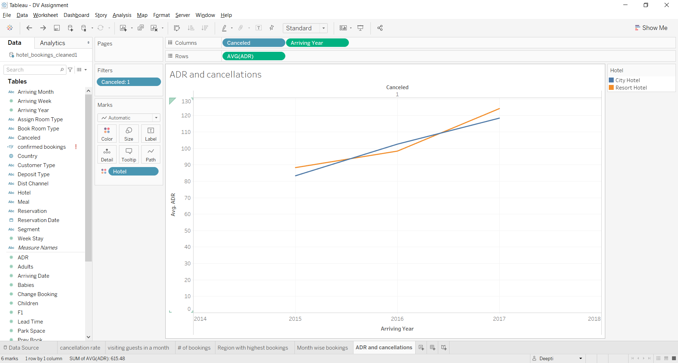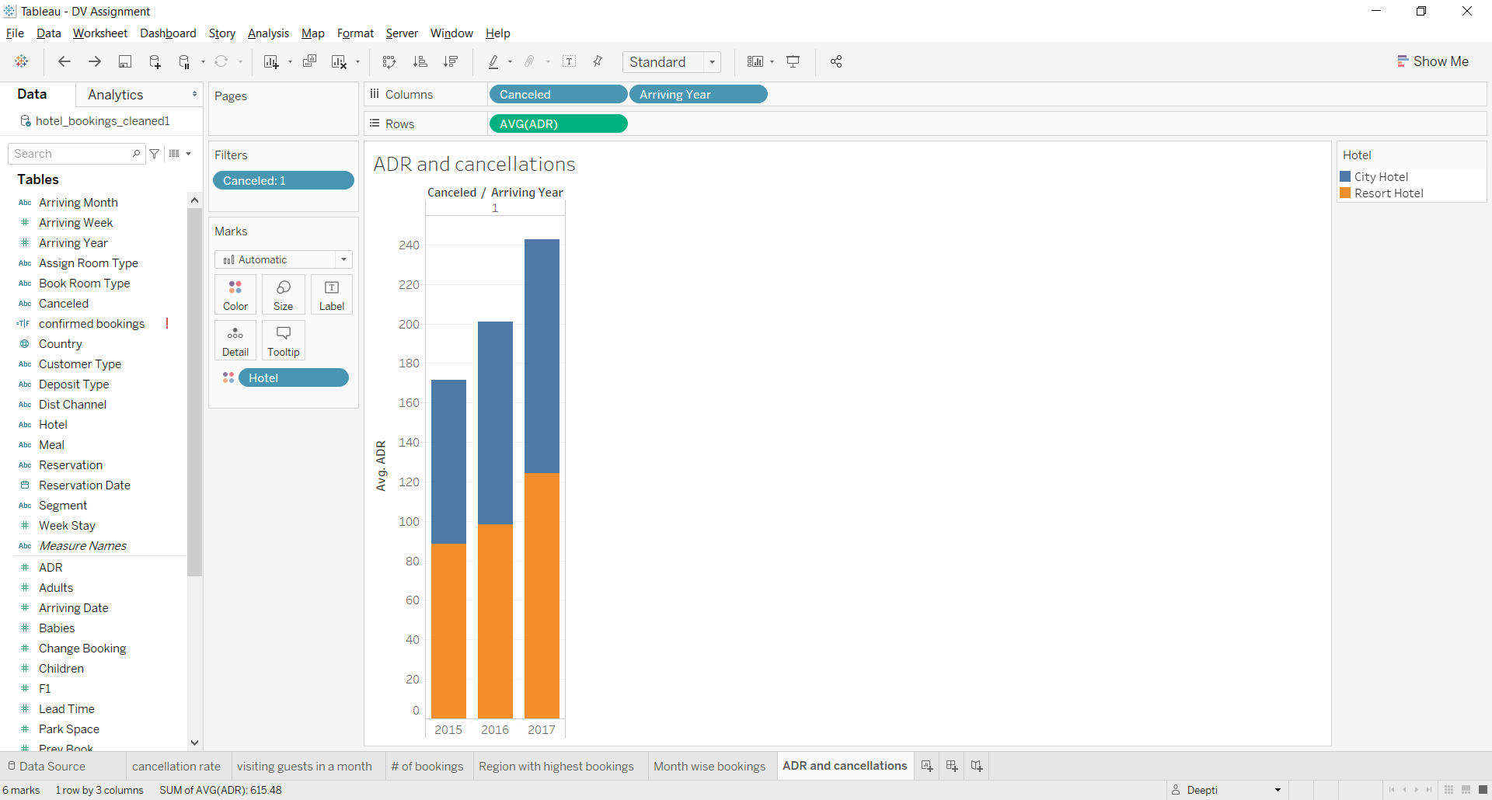

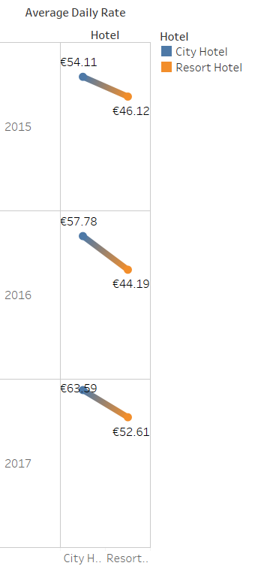

**Previous Iterations of Insights:**

**Booking Ratio:**

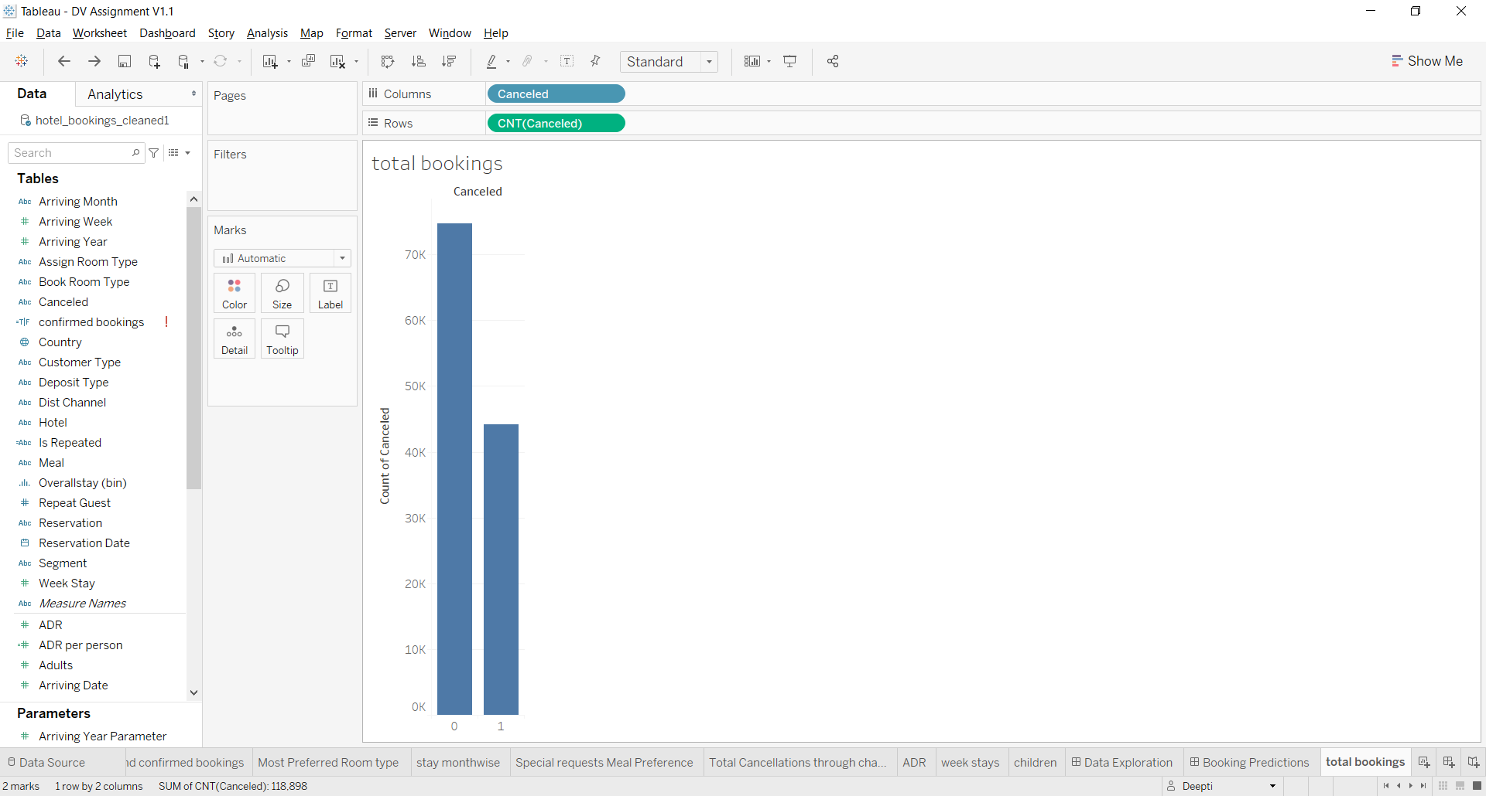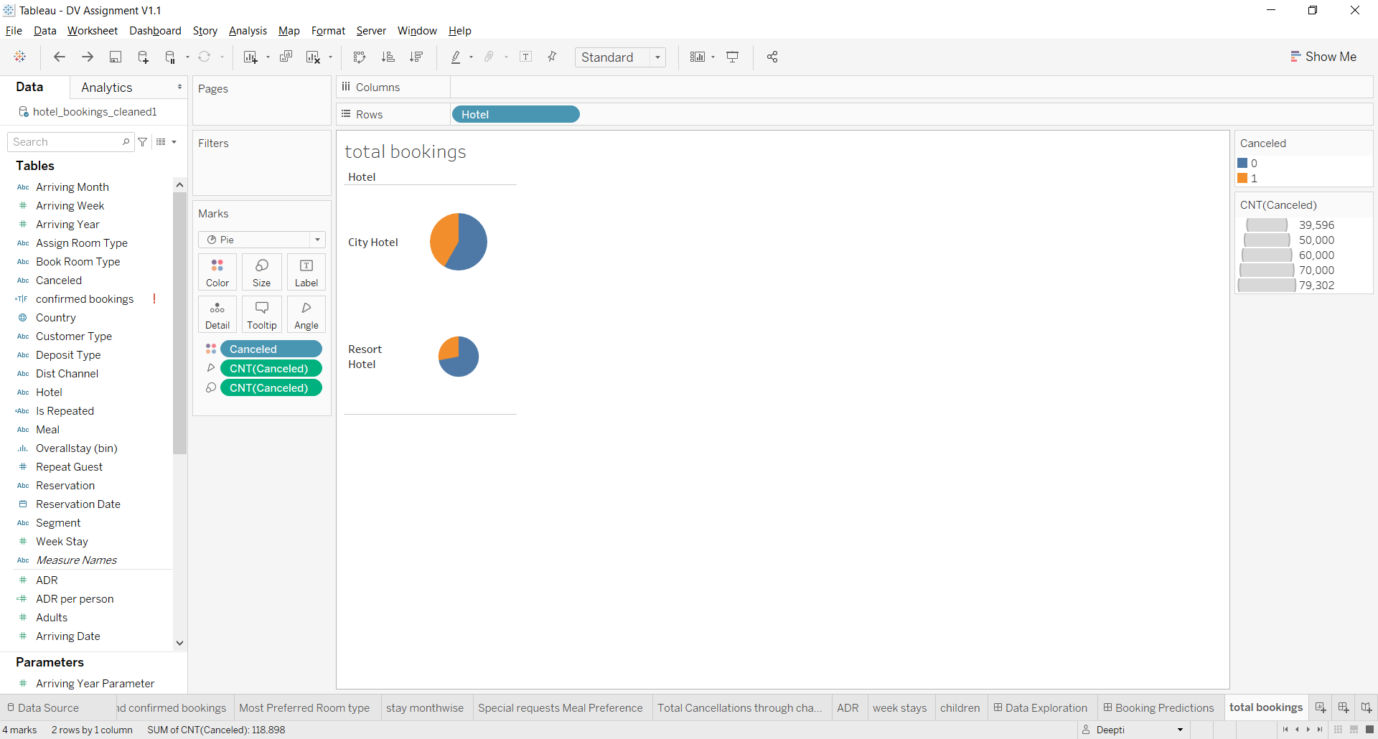

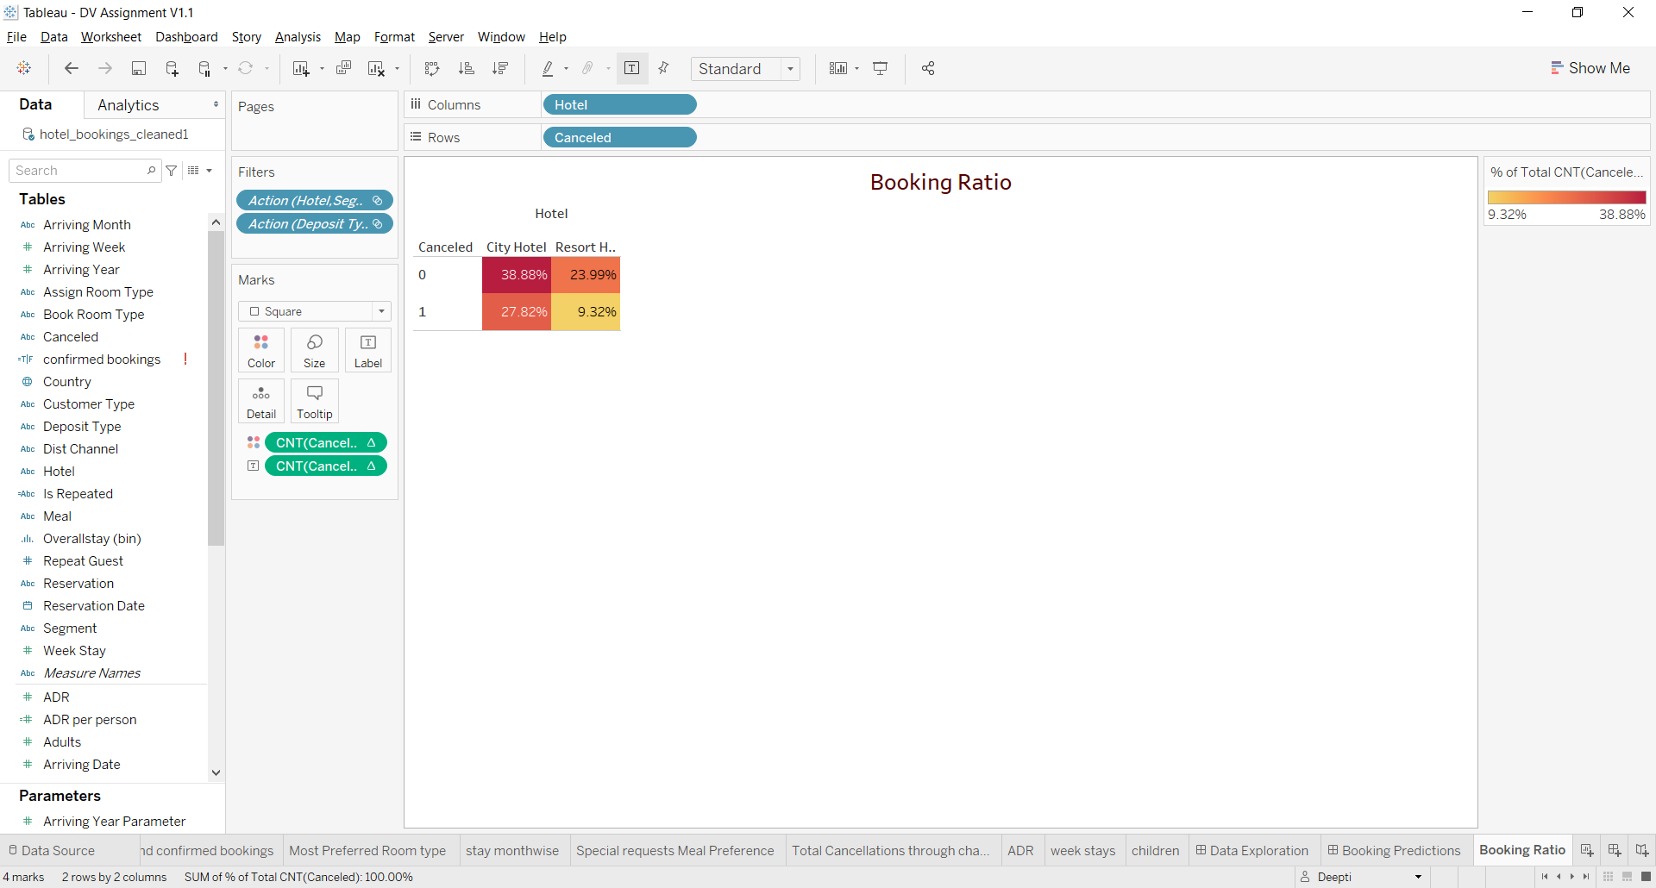

**Average Lead time of customer type:**

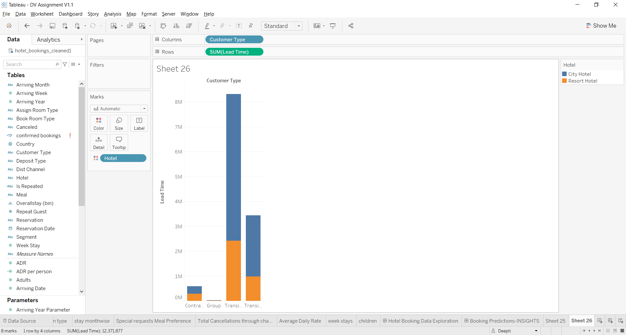 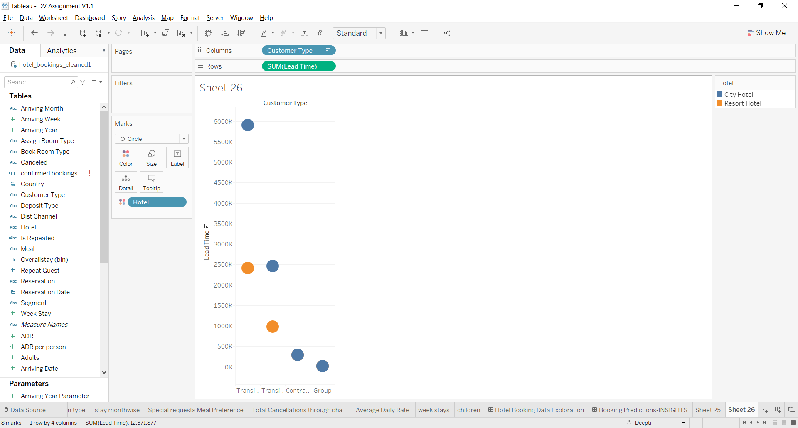

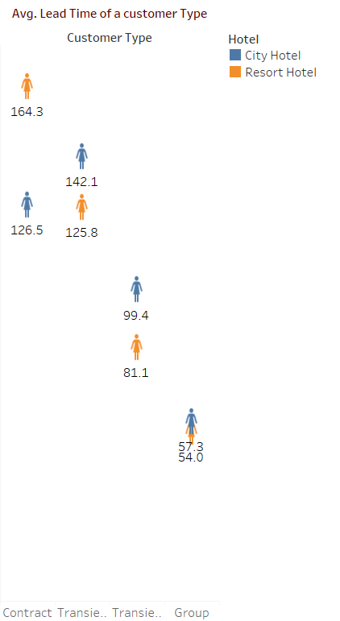

**Deposit Type:**

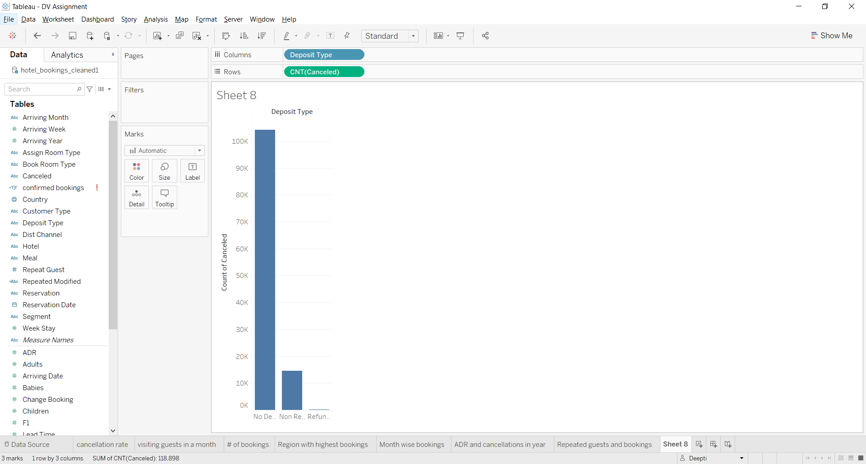 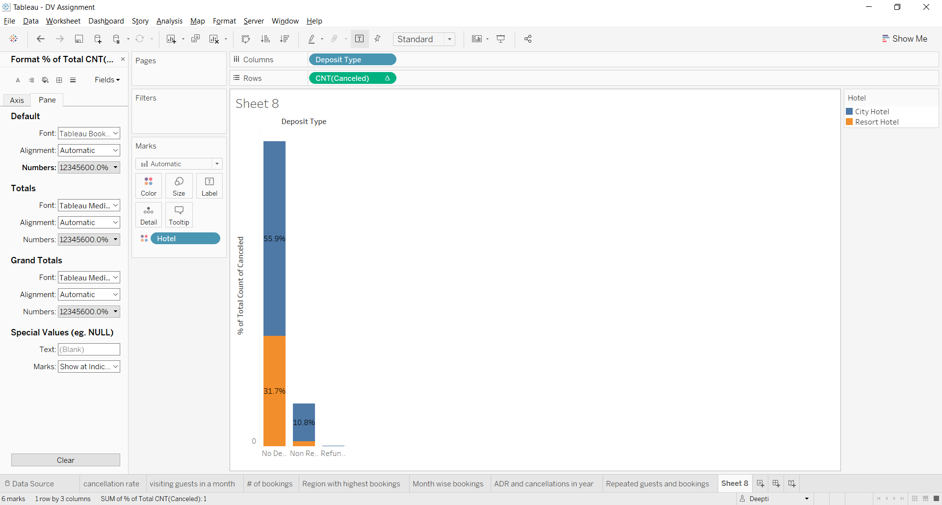

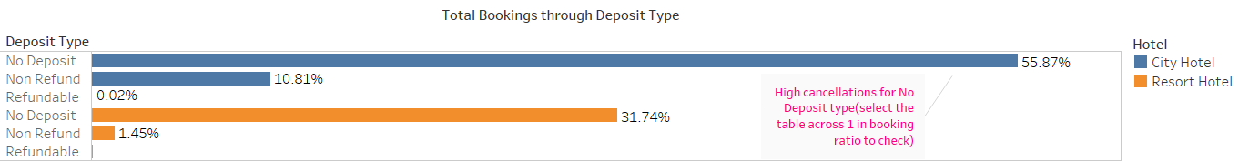

**Bookings through Segment:**

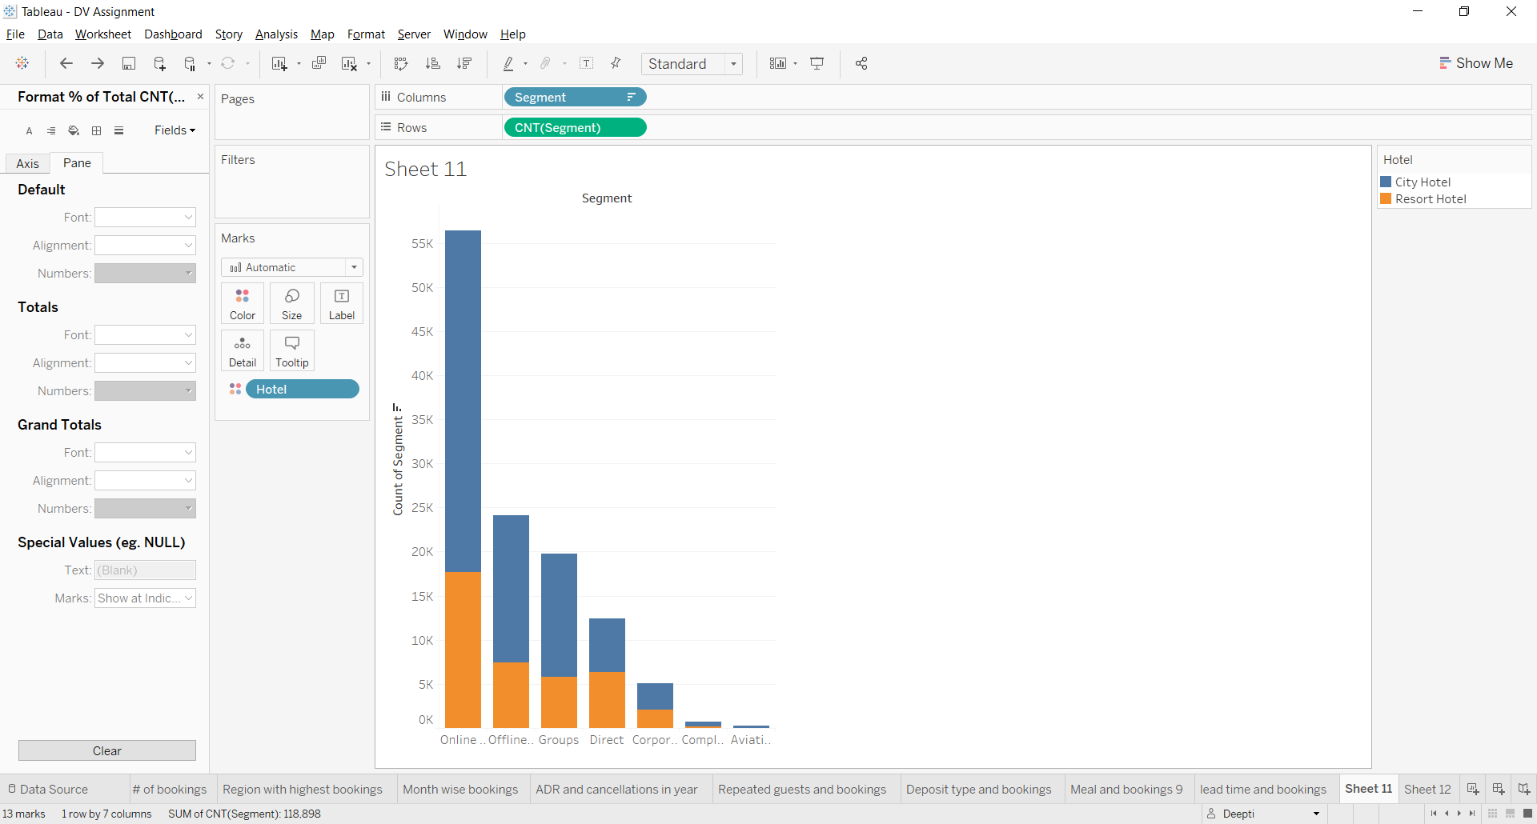 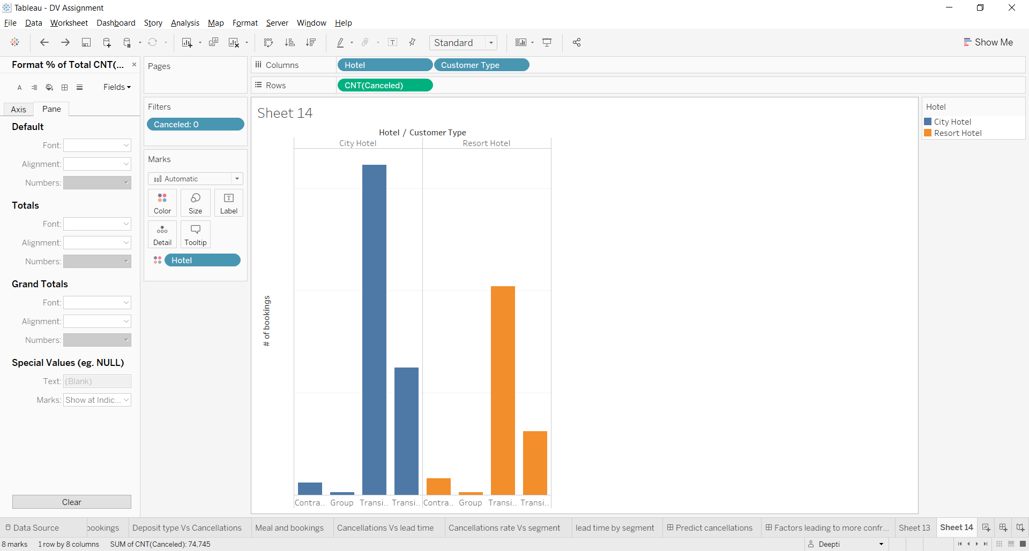

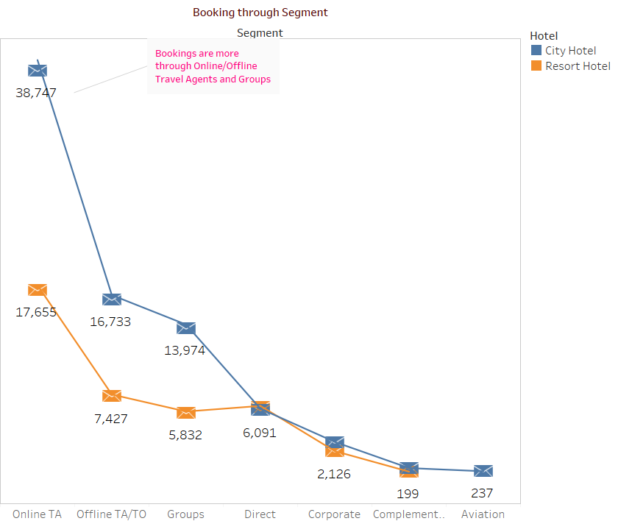

**Region and Avg Week stay:**

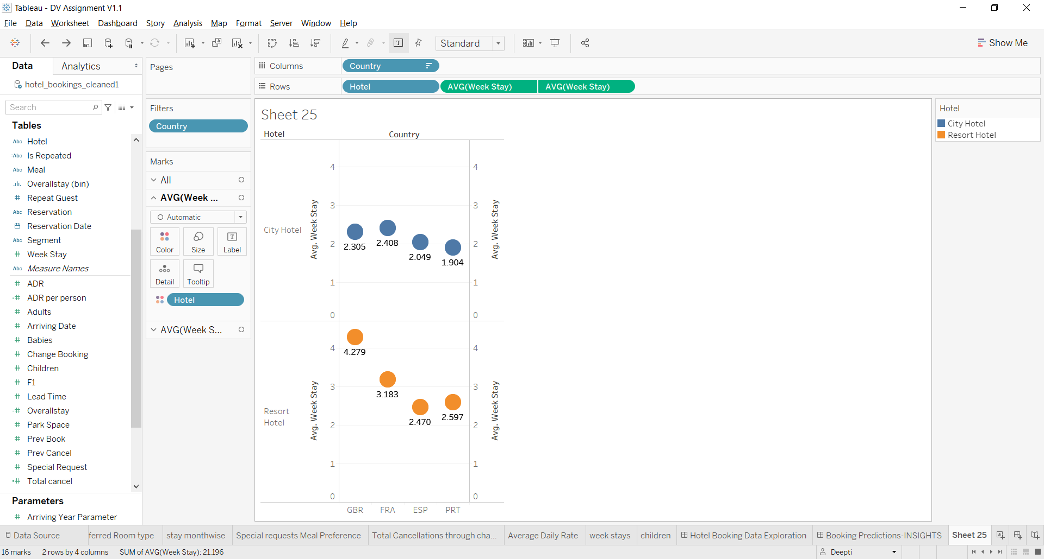 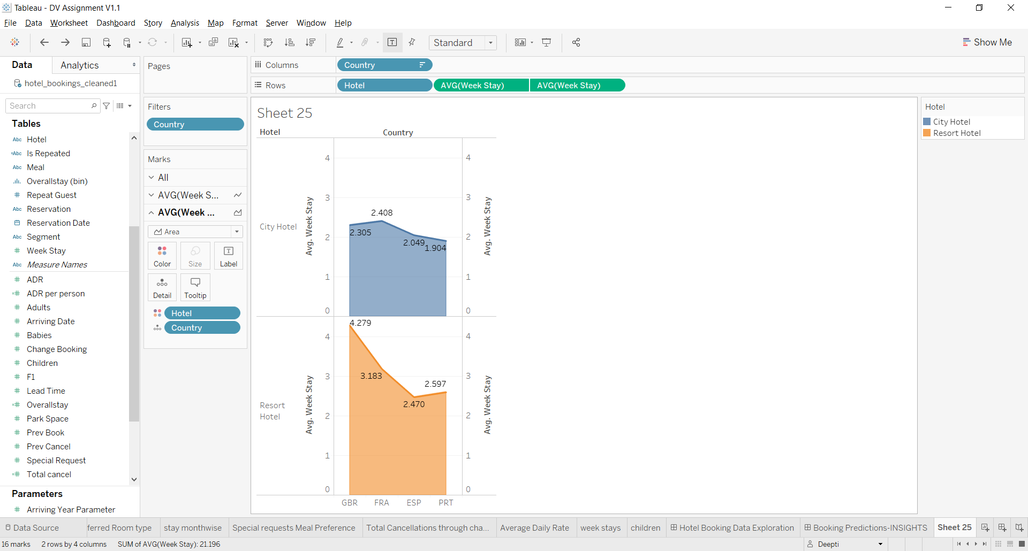

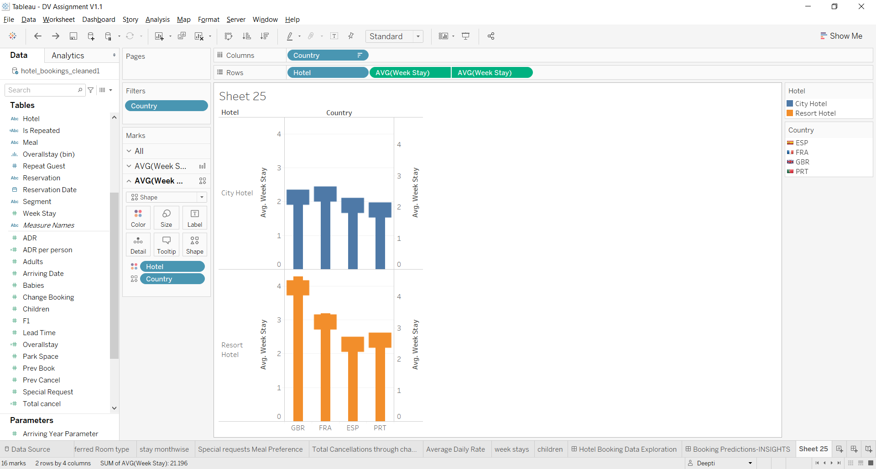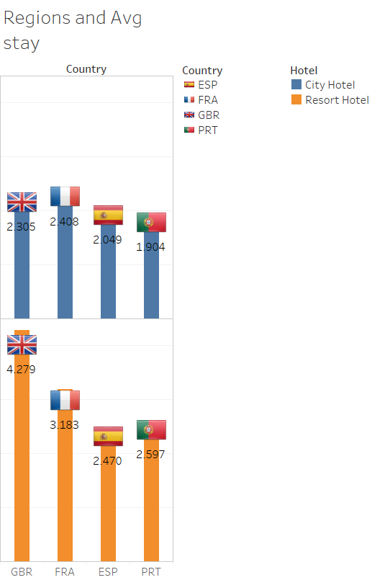

Other Data Explorations Previous Iterations: Not used in any of the dashboards:

**Arriving Month and cancellations:**

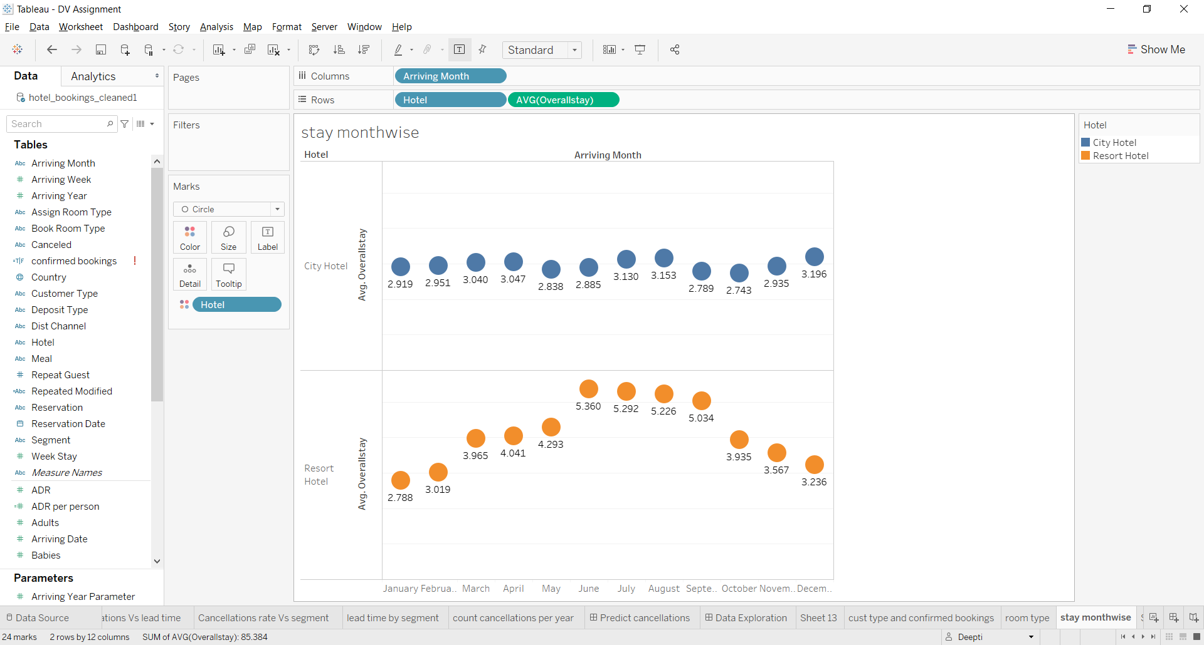 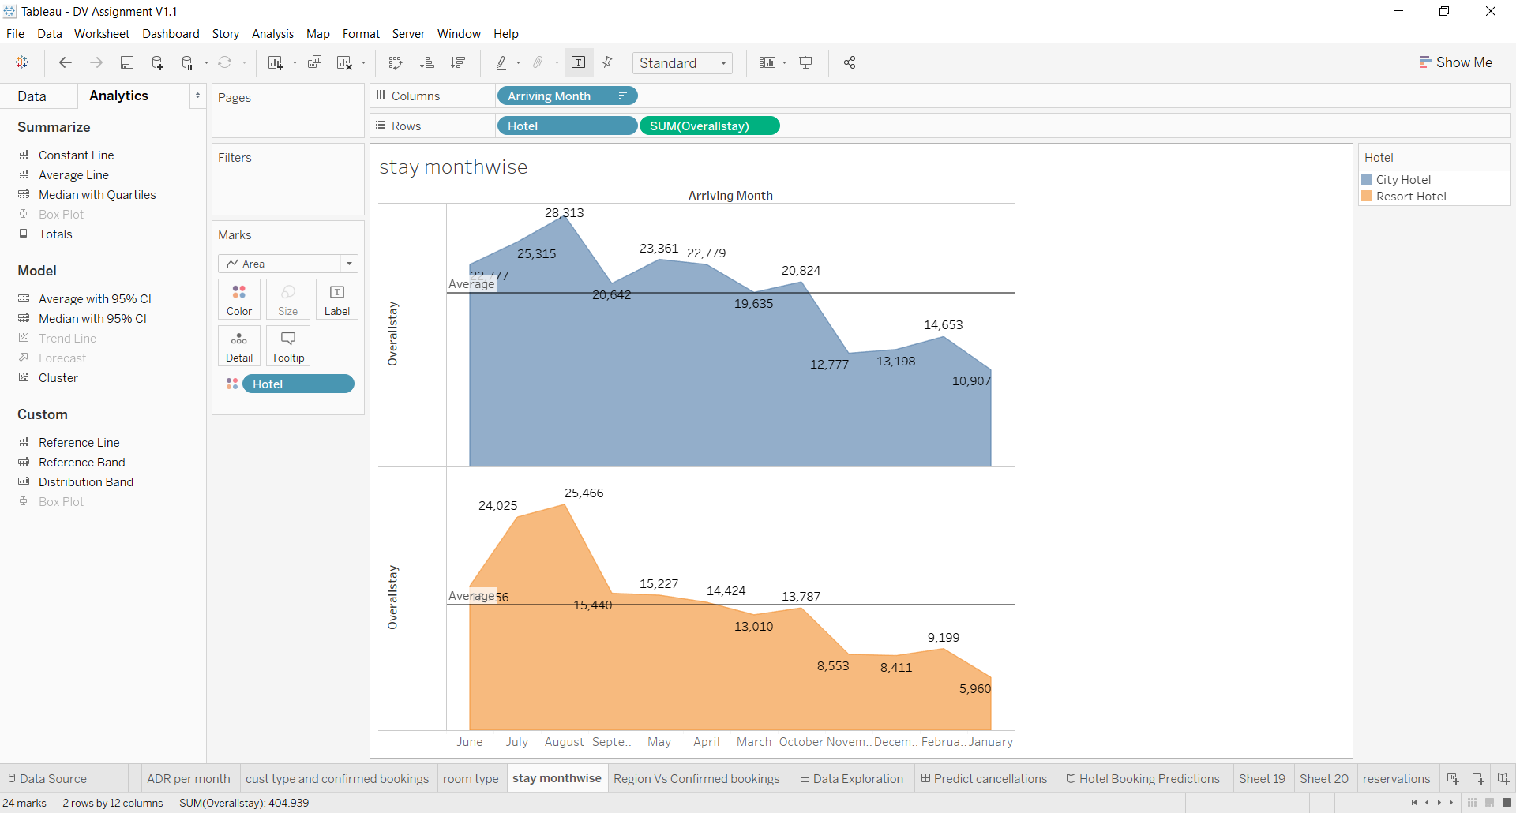

Monthly Change bookings:

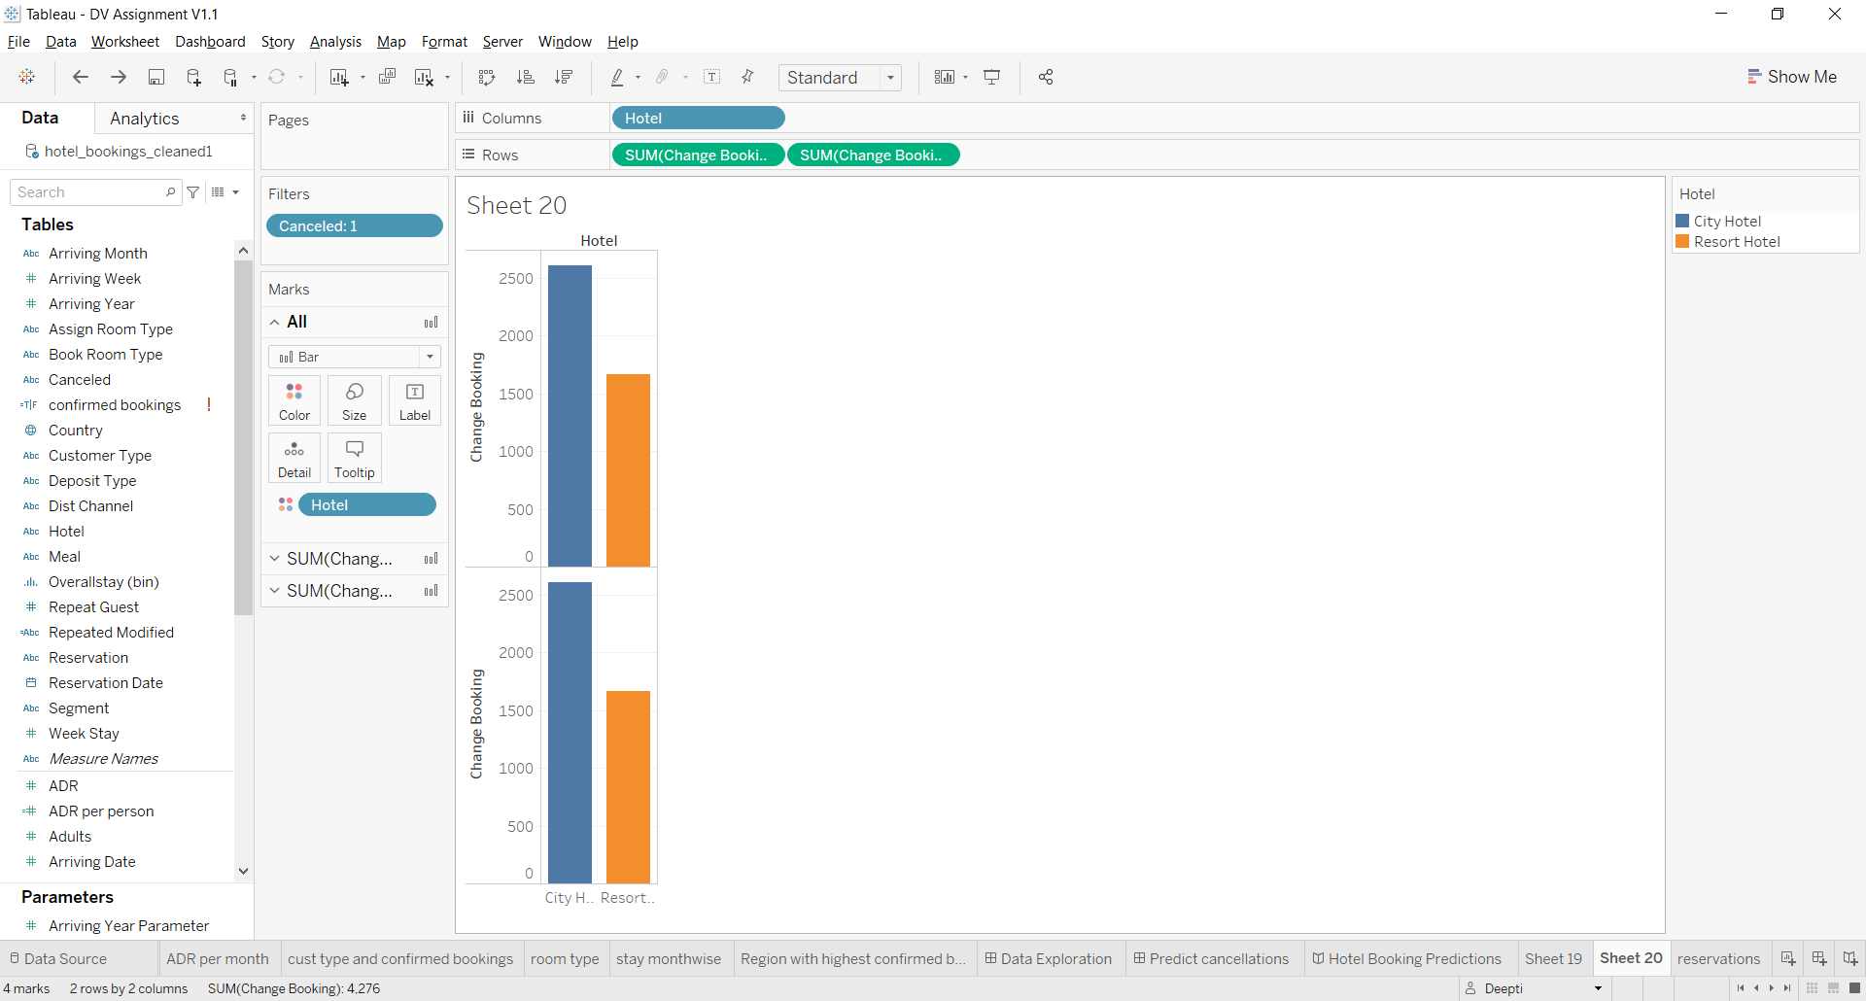 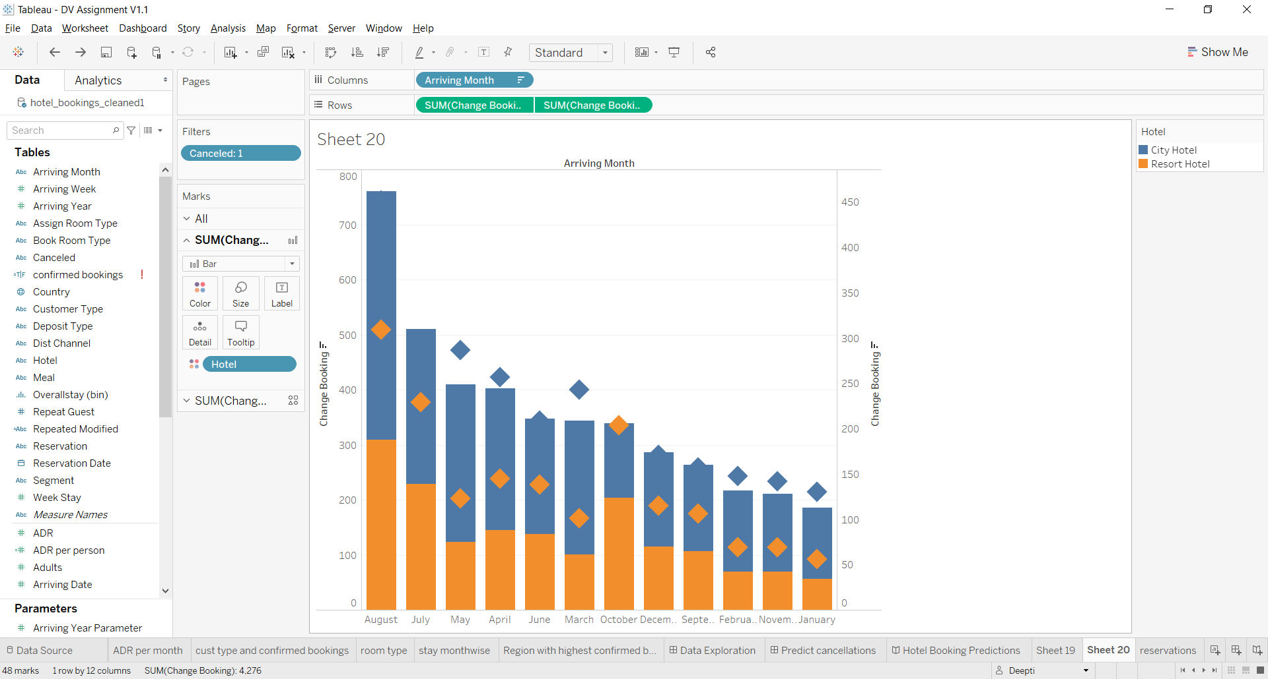

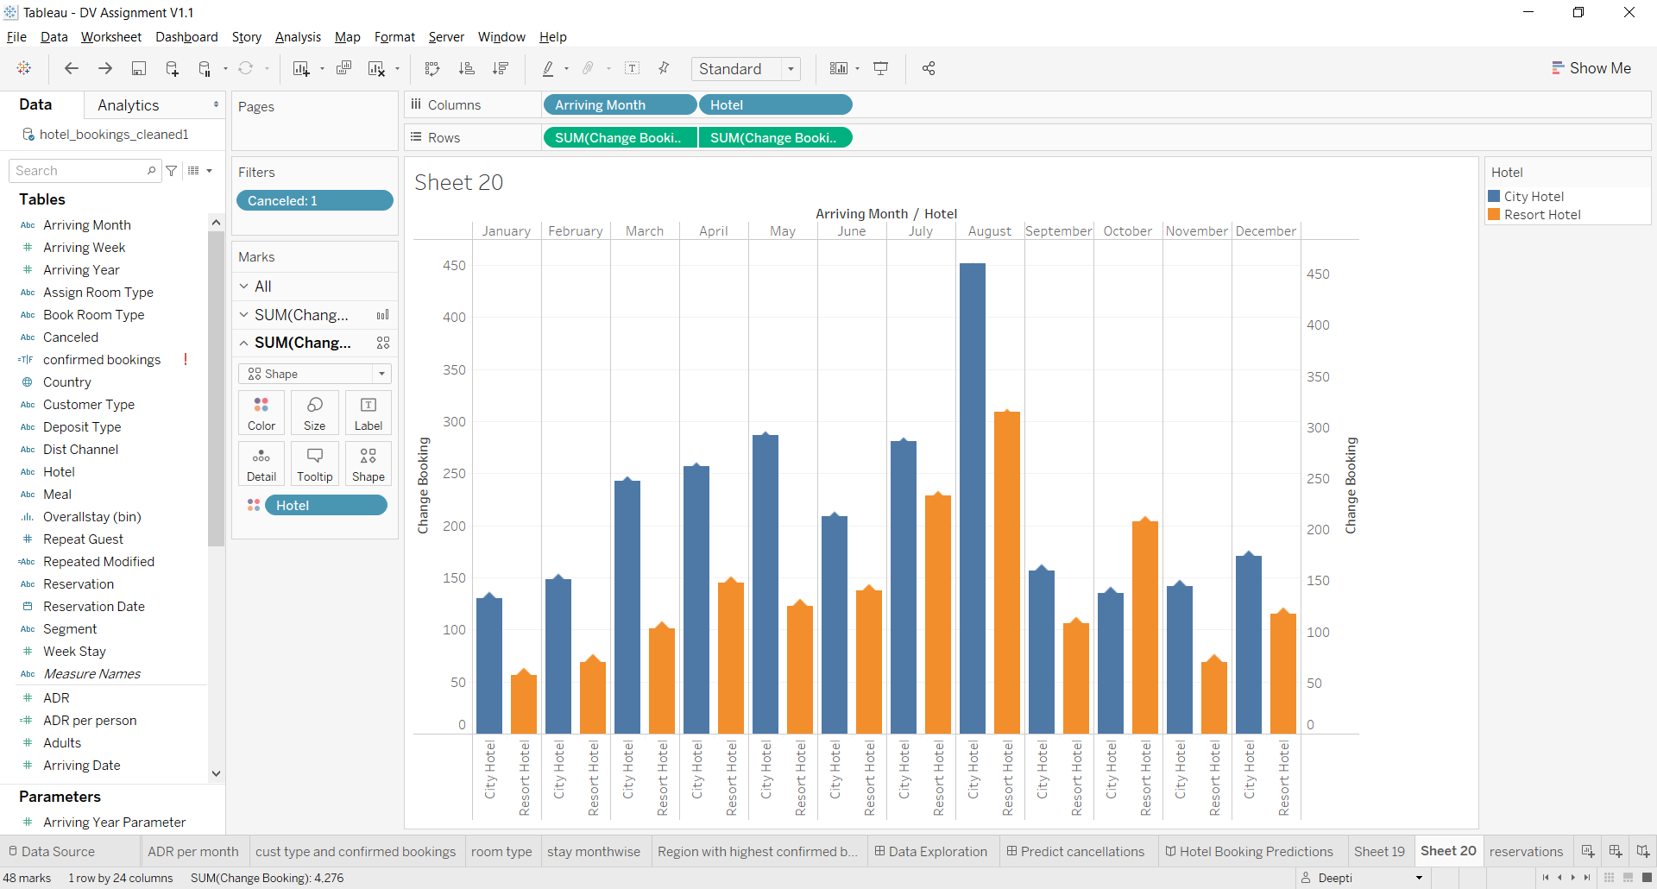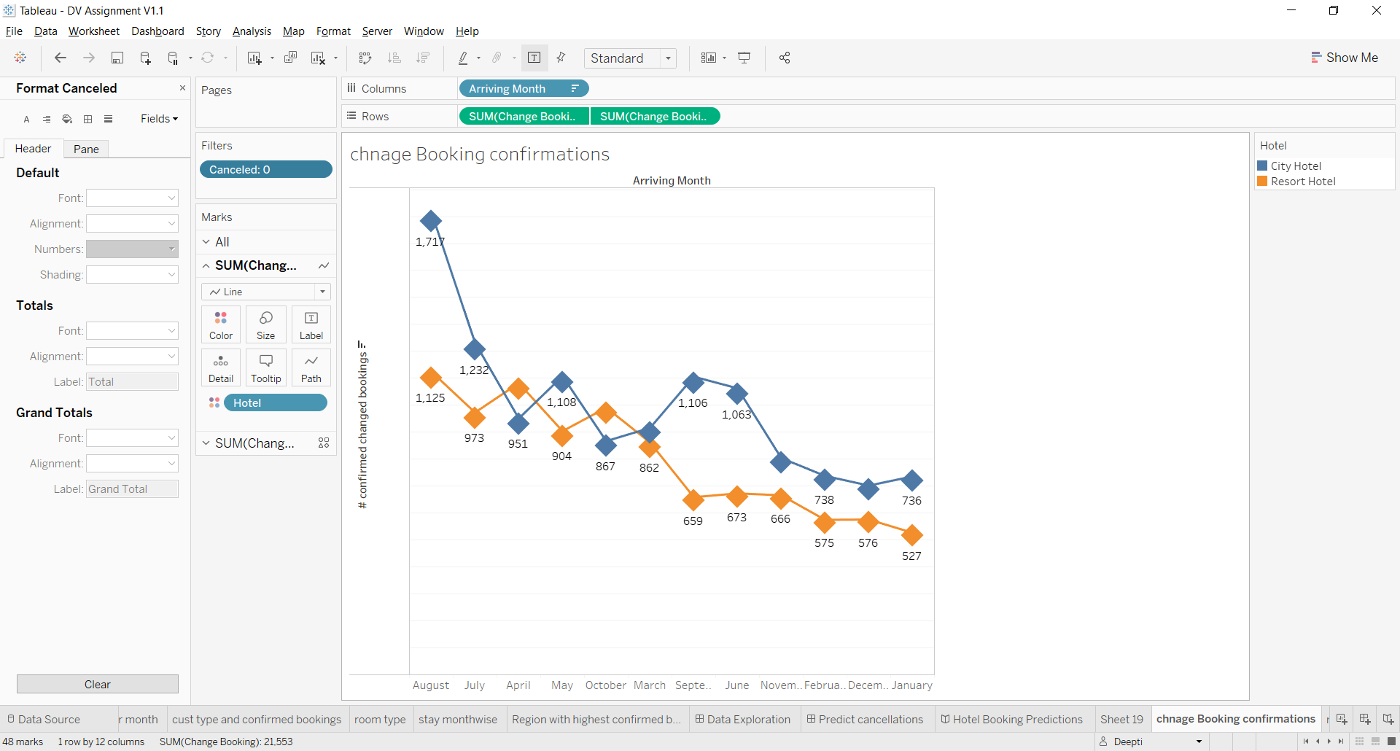

**Monthly Reservations**:

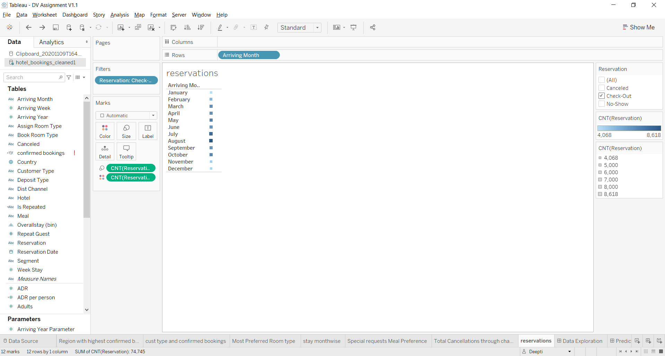 

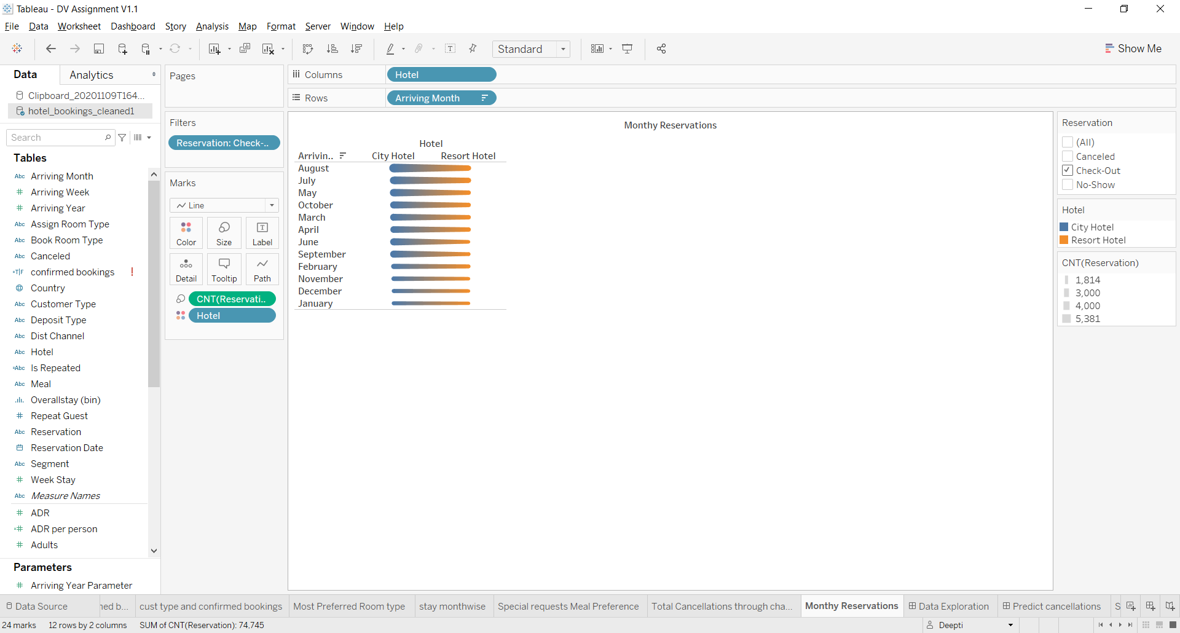

cancellation Rate:

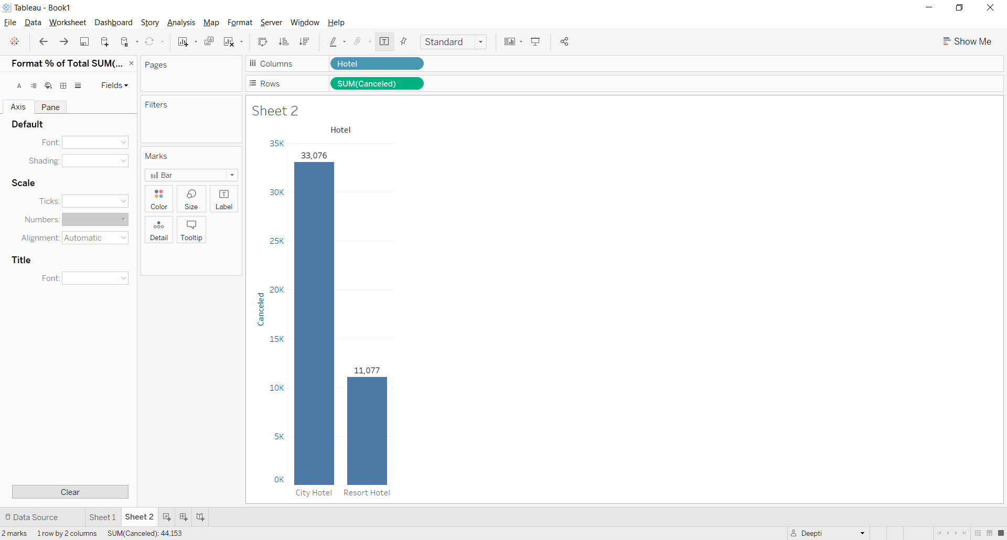 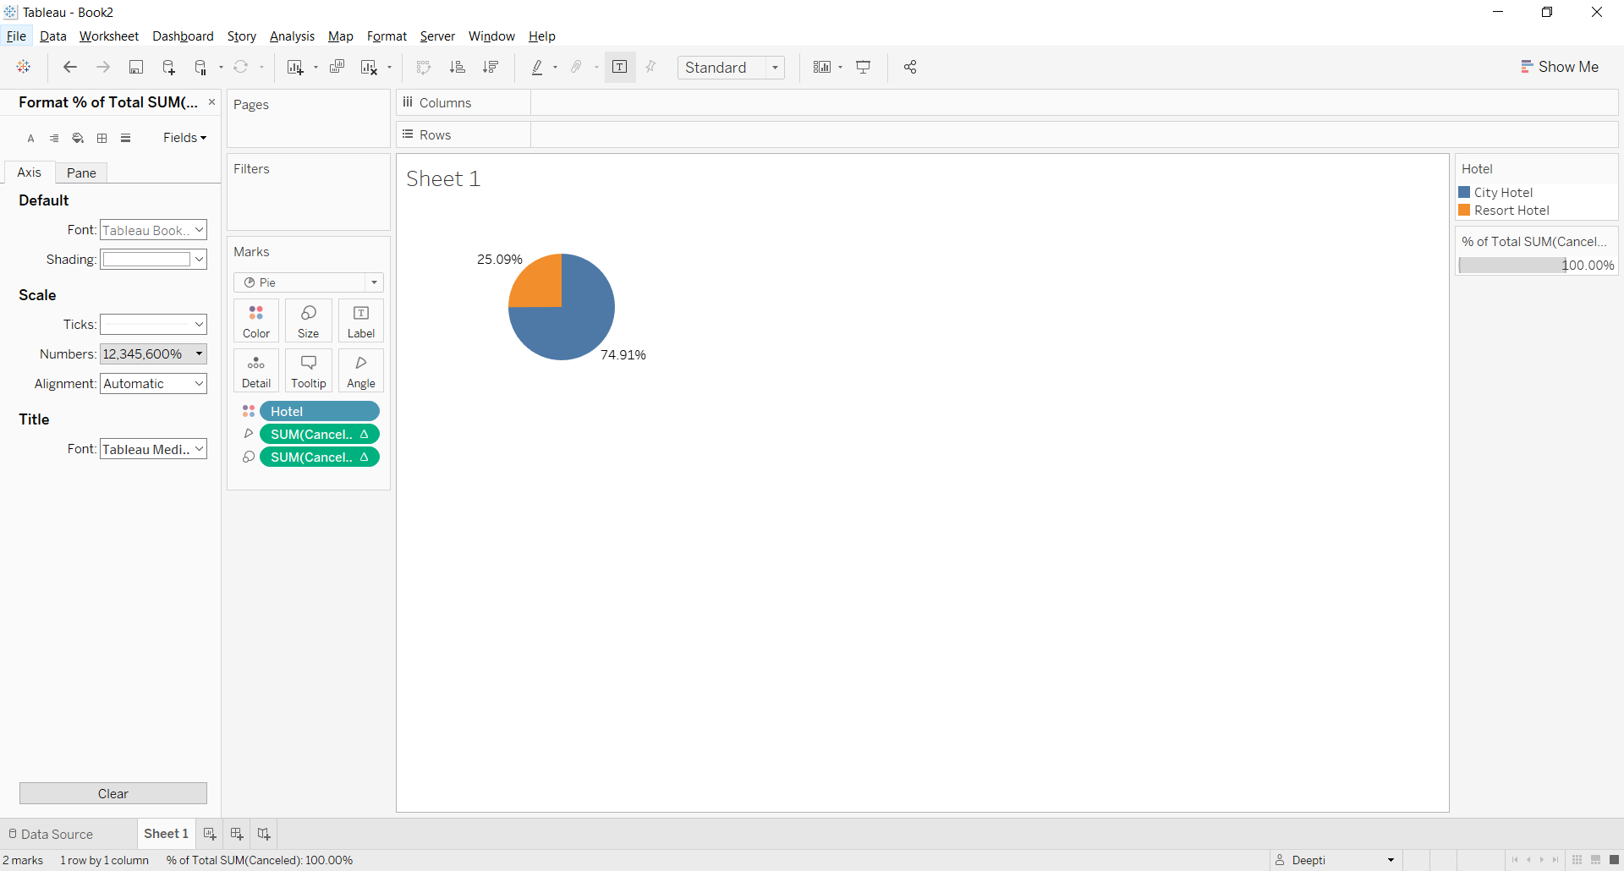

References:

*Antonio et al. - 2019—Hotel booking demand datasets.pdf. (n.d.).* Retrieved from Retrieved from[https://www.sciencedirect.com/science/article/pii/S2352340918315191](https://www.sciencedirect.com/science/article/pii/S2352340918315191%20)

*Hotel booking demand*. (n.d.). Retrieved November 2, 2020, from <https://kaggle.com/jessemostipak/hotel-booking-demand>

*Hotel Booking Demand—Melissa Tao | Tableau Public*. (n.d.). Retrieved November 2, 2020, from <https://public.tableau.com/profile/melissa.tao#!/vizhome/HotelBookingDemand_16021249965490/HotelBookingOverview>